

|  |  |
| --- | --- |
|  |  |
| **USEFUL JAPANESE DICTIONARY FOR VIETNAMESE**  ソフトウェア要求仕様書 | | |
|  | | |

プロジェクト·コード: UJD_VN

ドキュメント·コード: UJD_VN_ソフトウェア要求仕様書_v1.2

- 　ハノイ, 2014年6月　 -

変更履歴

* A -追加、M - 修正、D – 削除

|  |  |  |  |  |
| --- | --- | --- | --- | --- |
| 発効日 | 変更項目 | A* M, D | 変更内容 | 版数 |
| 07/06/2014 | Add new | A |  | v0.1 |
| 14/06/2014 | Change 1.6 functional specification | M | Update functionality follow comments of supervisor | v0.3 |
| 23/06/2014 | Change 1.6 functional specification | M | Update functionality follow comments of supervisor. | v0.6 |
| 30/06/2014 | Change 1.6 functional specification | M | Update functionality follow comments of supervisor. | v1.0 |
| 05/08/2014 | Change 1.5 Entity Relation Model | M | Update model | v1.1 |
|  |  |  |  |  |

署名ページ

**作成者:** Nguyễn Ngọc Tuấn 23/06/2014

Team member

**レビュー者：**  Nguyễn Ngọc Tuấn

Team member

**承認者：** Nguyễn Văn Sang

Supervisor

目次

1.1 はじめに 5

1.1.1 目的 5

1.1.2 定義 5

1.2 システム意思 5

1.3 スコープ 5

1.4 オーバーオールデスクリプション 5

1.4.1 システムオーバービュー 5

1.4.2 産物面立ち 7

1.4.3 使用者性状 10

1.4.4 ユーザードキュメンテーション 10

1.4.5 仮定 10

1.5 エンティティ · リレーション · モデル 11

1.5.1 エンティティ続き柄図表 11

1.5.2 エンティティ · デテール 11

1.6 機能的仕様 22

1.6.1 コモン•モジュール 22

1.6.2 アカウント•マネージメント•モジュール 32

1.6.3 コンタック•アドミン • モジュール 44

1.6.4 プラクティス•マネージメント•モジュール 53

1.6.5 アドミンアカウント•マネージメント 64

1.6.6 メンバーアカウント•マネージメント 71

1.6.7 言葉•マネージメント 78

1.6.8 文法•マネージメント 91

1.6.9 リーディング•ドキュメント•マネージメント 103

1.6.10 会話•マネージメント 120

1.6.11 ビデオ·マネージメント 135

1.6.12 リスニング·マネージメント 145

1.6.13 テスト·マネージメント 159

1.6.14 貢献識見·マネージメント 172

1.6.15 貢献含量マネージメント 180

1.7 不機能的明示 188

1.7.1 確実 188

1.7.2 実行·要件 188

1.7.3 ユーザーインターフェ 189

1.7.4 保守性 189

1.7.5 ユーザビリティ 189

1.7.6 担保要件 189

1.7.7 金物 · ソフトウェア要件 190

## はじめに

### 目的

This document is created as the introduction for project Useful Japanese Dictionary for Vietnamese – our Capstone Project at FPT University. In this document, we will descript the overview of some existing systems, the initial idea for our project, a brief description about our expected system and some potential risks, critical assumptions, constrains. Moreover, this document also shows opportunities what it offers for users.

### 定義

This section describes the definitions, terms, and acronyms that are used in software requirements specification.

|  |  |
| --- | --- |
| Items | Description |
| UJD_VN | Useful Japanese dictionary for Vietnamese |
|  |  |
|  |  |

**Table 3-1: Definition and Acronyms**

## システム意思

That system is developed to help user easily find out information about Japanese (grammar, vocabulary, etc...) and training skill, doing test.

## スコープ

The scope of this project contains Requirement Analysis, Design, Coding and Testing (Unit Test, Integration Test, and System Test).

## オーバーオールデスクリプション

### システムオーバービュー

Nowadays, there are many dictionaries which support Japanese. That can be a website or mobile application. All of them have been created for the purpose of helping users search vocabulary or studying Japanese more easily. But we found some disadvantages which existing in website which support users studying Japanese. So, our project – UJD_VN will include some main functions of existing dictionary website and add some special features such as showing examples by Vietnamese, supporting searching specialized vocabulary or users can contribute idea, good knowledge to make our database become larger. Moreover, we will provide freely website to users. Here, we toward provide website for Vietnamese who want to studying Japanese communication or who want to join Japanese certification exams.

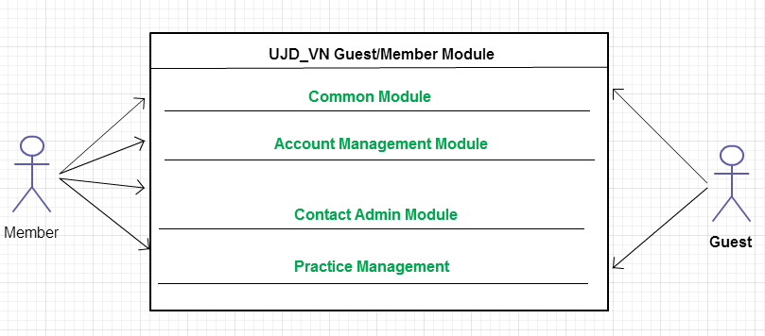

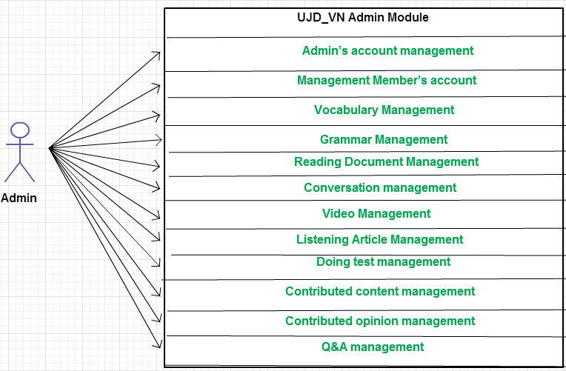

### 産物面立ち

|  |  |  |  |
| --- | --- | --- | --- |
| **Use Case No.** | **Group of functions** | **Functions** | **Glossary** |
| **UJD_VN GUEST/MEMBER MODULE** | | | |
| **Common Module** | | | |
|  | Search | Search sentences | Tìm kiếm các mẫu câu ví dụ |
|  | Search conversation | Tìm kiếm các đoạn hội thoại |
|  | Search grammar | Tìm kiếm ngữ pháp |
|  | Search video | Tìm kiếm Video tiếng Nhật |
|  | Search specialized Japanese | Tìm kiếm Tiếng Nhật chuyền ngành |
| **Account Management Module** | | | |
|  | Login | Login by Facebook account | Đăng nhập bằng tài khoản Facebook |
| Login by Google account | Đăng nhập bằng tài khoản Google |
| Login by registered account | Đăng nhập bằng tài khoản tự đăng kí |
|  |  | Logout | Đăng xuất |
|  |  | Register | Đăng kí tài khoản cho khách để sử dụng nhiều chức năng hơn của website |
|  |  | Edit Profile | Chỉnh sửa thông tin cá nhân |
|  |  | Forgot Password | Quên mật khẩu |
| **Contact Admin Module** | | | |
|  | Contact Admin | Contribute content | Đóng góp database hữu ích cho website |
|  | Contribute opinion | Đóng góp ý kiến để phát triển trang web |
|  | Send Q & A | Gửi câu hỏi thắc mắc trong quá trình sử dụng Website |
| **Practice Management** | | | |
|  | Doing Test | Test | Làm bài kiểm tra trắc nghiệm |
| Tracking mark | Theo dõi quá trình học tập |
|  |  | Training Listening | Luyện Nghe trình độ N2,N3,N4 |
|  |  | Listening conversation | Nghe hội thoại |
|  |  | Reading Document | Đọc tài liệu |
| **UJD_VN ADMIN MODULE** | | | |
|  | Admin’s account management | Add new admin | Thêm mới admin |
|  | Edit profile | Chỉnh sửa thông tin admin |
|  | Delete admin | Xóa thông tin admin |
|  | Management Member’s account | Search member | Tìm kiếm thành viên |
|  | Ban/Unban Member’s account | Khóa/Mở khóa tài khoản thành viên |
|  | Delete member | Xóa thành viên |
|  | Vocabulary Management | Search vocabulary | Tìm kiếm từ vựng |
|  | Add vocabulary | Thêm mới từ vựng |
|  | Edit vocabulary | Chỉnh sửa thông tin từ vựng |
|  | Delete vocabulary | Xóa từ vựng |
|  | Grammar Management | Search grammar | Tìm kiếm ngữ pháp |
|  | Add Grammar | Thêm ngữ pháp mới |
|  | Edit grammar | Chỉnh sửa ngữ pháp |
|  | Delete Grammar | Xóa ngứ pháp |
|  | Reading Document Management | Search reading document | Tìm kiếm các bài đọc |
|  | Add reading document | Thêm mới các bài đọc |
|  | Edit reading document | Chỉnh sửa thông tin các bài đọc |
|  | Delete reading document | Xóa các bài đọc |
|  | Conversation management | Search conversation | Tìm kiếm các bài hội thoại |
|  | Add conversation | Thêm mới bài hội thoại |
|  | Edit conversation | Chỉnh sửa bài hội thoại |
|  | Delete conversation | Xóa bài hội thoại |
|  | Video Management | Search Video | Tìm kiếm Video bằng tiêu đề |
|  | Add Video | Thêm mới video |
|  | Edit Video | Chỉnh sửa nội dung liên quan đến video như tiêu đề. |
|  | Delete Video | Xóa video |
|  | Listening Article Management | Search listening article | Tìm kiếm các bài nghe |
|  | Add listening article | Thêm mới các bài nghe |
|  | Edit listening article | Chỉnh sửa các bài nghe |
|  | Delete listening article | Xóa các bài nghe |
|  | Doing test management | Search test | Tìm kiếm bài kiểm tra |
|  | Add test | Thêm mới bài kiểm tra |
|  | Edit test | Chỉnh sửa bài kiếm tra |
|  | Delete test | Xóa bài kiểm tra |
| **Contact’s Content Management** | | | |
|  | Contributed content management | Search contribute content | Tìm kiếm nội dung đóng góp |
| Approve content | Chấp nhận ý kiến đóng góp |
| Reply user | Trả lời người dùng |
| Delete content | Xóa nội dung đóng góp |
|  | Contributed opinion management | Search contribute opinion | Tìm kiếm ý kiến đóng góp |
| Reply user | Phản hồi lại ý kiến người dùng |
| Delete opinion | Xóa ý kiến đóng góp |
|  | Q & A Management | Search Q & A | Tìm kiếm Q & A |
| Reply Q & A | Trả lời Q & A |
| Delete Q & A | Xóa Q & A |

### 使用者性状

This website developed towards those who have achieved elementary level Japanese and want to improve intermediate level. The website requires users to have the ability to use a browser with an internet connection. Use can easy use the functions in website, but if they want to use all function, they must be login.

### ユーザードキュメンテーション

List of document when delivering this application is in the table below:

|  |  |
| --- | --- |
| Name | Description |
| User Manual | Provide detailed explanation about the system, screens and guide users how to use all features of UJD_VN website. |

### 仮定

* Receive the guidance and good support of teacher.
* No one of member got sick in the software development process.
* In the development process, no device got fail.
* Every report meets the deadline.
* Team member do not conflict in the work process.

## エンティティ · リレーション · モデル

### エンティティ続き柄図表

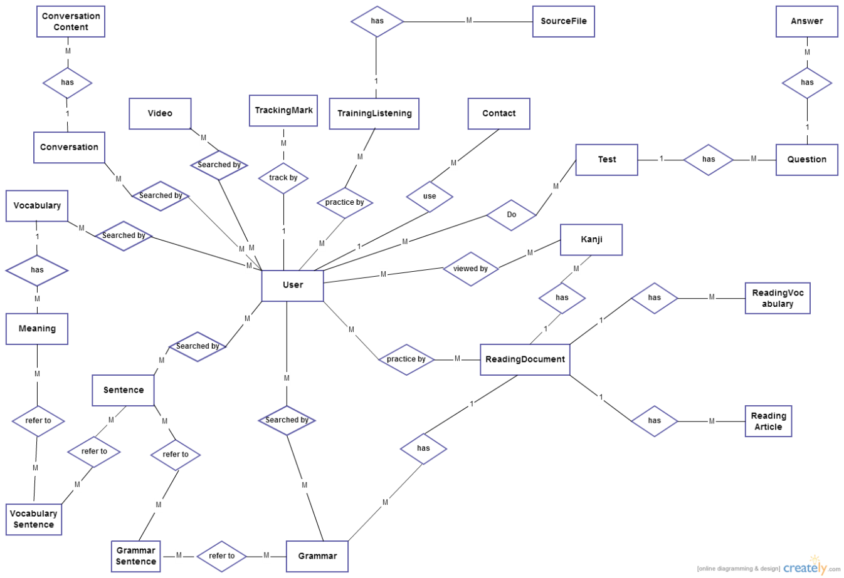

### エンティティ · デテール

#### 言葉

|  |  |  |  |  |  |  |  |  |  |
| --- | --- | --- | --- | --- | --- | --- | --- | --- | --- |
| No | Field Name | Type | Length | Size | Null | Unique | P/F Key | Default | Description |
|  | v_id | Int |  |  |  |  | P |  | PRIMARY KEY  This is automatically increase value 1 |
|  | v_hiragana | varchar | 200 |  |  |  |  |  | Vocabulary’s hiragana |
|  | v_romaji | Varchar | 200 |  |  |  |  |  | Vocabulary’s romaji |
|  | v_status | int |  |  |  |  |  |  | Vocabulary’s status |

#### 意味

|  |  |  |  |  |  |  |  |  |  |
| --- | --- | --- | --- | --- | --- | --- | --- | --- | --- |
| No | Field Name | Type | Length | Size | Null | Unique | P/F Key | Default | Description |
|  | m_id | Int |  |  |  |  | P |  | PRIMARY KEY  This is automatically increase value 1 |
|  | v_id | Int |  |  |  |  | FK |  | Foreign key to Vocabulary |
|  | m_meaningvn | varchar | 500 |  |  |  |  |  | Meaning of vocabulary |
|  | m_category | Varchar | 10 |  |  |  |  |  | Category of vocabulary |
|  | m_kanji | Varchar | 10 |  | Y |  |  |  | Kanji of vocabulary |
|  | m_specialized | varchar | 200 |  |  |  |  |  | Vocabulary’s specialized |

#### 言葉ー文章

|  |  |  |  |  |  |  |  |  |  |
| --- | --- | --- | --- | --- | --- | --- | --- | --- | --- |
| No | Field Name | Type | Length | Size | Null | Unique | P/F Key | Default | Description |
|  | m_id | Int |  |  |  |  | FK |  | Foreign key to Meaning |
|  | s_id | Int |  |  |  |  | FK |  | Foreign key to Sentence |

#### 文章

|  |  |  |  |  |  |  |  |  |  |
| --- | --- | --- | --- | --- | --- | --- | --- | --- | --- |
| No | Field Name | Type | Length | Size | Null | Unique | P/F Key | Default | Description |
|  | s_id | Int |  |  |  |  | P |  | PRIMARY KEY  This is automatically increase value 1 |
|  | s_hiragana | varchar | 1000 |  |  |  |  |  | Sentence’s hiragana |
|  | s_romaji | Varchar | 1000 |  |  |  |  |  | Sentence’s romaji |
|  | s_meaning | varchar | 1000 |  |  |  |  |  | Sentence’s meaning |
|  | s_kanji | varchar | 1000 |  |  |  |  |  | Sentence’s kanji |

#### 文法

|  |  |  |  |  |  |  |  |  |  |
| --- | --- | --- | --- | --- | --- | --- | --- | --- | --- |
| No | Field Name | Type | Length | Size | Null | Unique | P/F Key | Default | Description |
|  | g_id | Int |  |  |  |  | P |  | PRIMARY KEY  This is automatically increase value 1 |
|  | g_hiragana | varchar | 200 |  |  |  |  |  | Grammar’s hiragana |
|  | g_romaji | Varchar | 200 |  |  |  |  |  | Grammar’s romaji |
|  | g_level | Varchar | 10 |  |  |  |  |  | Grammar’s level |
|  | g_meaning | varchar | 200 |  |  |  |  |  | Grammar’s meaning |
|  | g_use | varchar | 1000 |  |  |  |  |  | Grammar’s use |
|  | g_status | int |  |  |  |  |  |  | Grammar’s status |
|  | reading_id | Varchar | 20 |  |  |  | FK |  | Foreign key to ReadingDocument |

#### 文法―文章

|  |  |  |  |  |  |  |  |  |  |
| --- | --- | --- | --- | --- | --- | --- | --- | --- | --- |
| No | Field Name | Type | Length | Size | Null | Unique | P/F Key | Default | Description |
|  | m_id | Int |  |  |  |  | FK |  | Foreign key to Meaning |
|  | s_id | Int |  |  |  |  | FK |  | Foreign key to Sentence |

#### ビデオ

|  |  |  |  |  |  |  |  |  |  |
| --- | --- | --- | --- | --- | --- | --- | --- | --- | --- |
| No | Field Name | Type | Length | Size | Null | Unique | P/F Key | Default | Description |
|  | vi_id | Int |  |  |  |  | P |  | PRIMARY KEY  This is automatically increase value 1 |
|  | vi_title | varchar | 200 |  |  |  |  |  | Video’s title |
|  | vi_link | varchar | 200 |  |  |  |  |  | Video’s link |

#### 漢字

|  |  |  |  |  |  |  |  |  |  |
| --- | --- | --- | --- | --- | --- | --- | --- | --- | --- |
| No | Field Name | Type | Length | Size | Null | Unique | P/F Key | Default | Description |
|  | k_id | Int |  |  |  |  | P |  | PRIMARY KEY  This is automatically increase value 1 |
|  | k_kanji | varchar | 10 |  |  |  |  |  | Kanji in Japanese |
|  | k_hanviet | varchar | 50 |  |  |  |  |  | Kanji’s Vietnamese-Han |
|  | k_onyomi | varchar | 100 |  |  |  |  |  | Kanji’s onyomi |
|  | k_kunyomi | varchar | 100 |  |  |  |  |  | Kanji’s kunyomi |
|  | k_meaning | varchar | 200 |  |  |  |  |  | Kanji’s meaning |
|  | k_level | varchar | 10 |  |  |  |  |  | Kanji’s level |
|  | k_status | int |  |  |  |  |  |  | Kanji’s status |
|  | reading_id | Varchar | 20 |  |  |  |  |  | Kanji’s readingdocument |

#### 会話

|  |  |  |  |  |  |  |  |  |  |
| --- | --- | --- | --- | --- | --- | --- | --- | --- | --- |
| No | Field Name | Type | Length | Size | Null | Unique | P/F Key | Default | Description |
|  | c_id | Varchar | 10 |  |  |  | P |  | PRIMARY KEY  This is automatically increase value 1 |
|  | c_level | varchar | 10 |  |  |  |  |  | Conversation’s level |
|  | c_title | varchar | 100 |  |  |  |  |  | Conversation’s title |
| 1. C_ | c_image | Varchar | 200 |  |  |  |  |  | Conversation’s image |

#### 会話含量

|  |  |  |  |  |  |  |  |  |  |
| --- | --- | --- | --- | --- | --- | --- | --- | --- | --- |
| No | Field Name | Type | Length | Size | Null | Unique | P/F Key | Default | Description |
|  | con_id | Int |  |  |  |  | P |  | PRIMARY KEY  This is automatically increase value 1 |
|  | c_id | Varchar | 10 |  |  |  | FK |  | Foreign key to Sentence |
|  | con_title | Varchar | 200 |  |  |  |  |  | Content’s title |
|  | con_hiragana | varchar | 5000 |  |  |  |  |  | Conversation’s hiragana |
|  | con_romaji | Varchar | 5000 |  |  |  |  |  | Conversation’s romaji |
|  | con_meaning | varchar | 5000 |  |  |  |  |  | Conversation’s meaning |
| 1. c | con_file | Varchar | 200 |  |  |  |  |  | File listen of conversation |

#### ユーザー

|  |  |  |  |  |  |  |  |  |  |
| --- | --- | --- | --- | --- | --- | --- | --- | --- | --- |
| No | Field Name | Type | Length | Size | Null | Unique | P/F Key | Default | Description |
|  | u_id | Int |  |  |  |  | P |  | PRIMARY KEY  This is automatically increase value 1 |
|  | u_username | Varchar | 32 |  |  | Y |  |  | Username login |
|  | u_password | Varchar | 32 |  |  |  |  |  | Store password login of user.  Using md5 algorithm. |
|  | u_role | int |  |  |  |  |  |  | Admin can assign permission for user |
|  | u_fullname | Varchar | 100 |  |  |  |  |  | User’s name display |
|  | u_email | Varchar | 100 |  |  | Y |  |  | User’s email |
|  | u_registerdate | Date |  |  |  |  |  |  | Date register |
|  | u_status | Int |  |  |  |  |  |  | Active or deactive |

#### コンタック

|  |  |  |  |  |  |  |  |  |  |
| --- | --- | --- | --- | --- | --- | --- | --- | --- | --- |
| No | Field Name | Type | Length | Size | Null | Unique | P/F Key | Default | Description |
|  | contact_id | Int |  |  |  |  | P |  | PRIMARY KEY  This is automatically increase value 1 |
|  | contact_email | varchar | 100 |  |  |  |  |  | Contact’s email |
|  | contact_content | varchar | 5000 |  |  |  |  |  | Contact’s content |
|  | contact_type | Varchar | 10 |  |  |  |  |  | Contact’s type |
|  | contact_status | int |  |  |  |  |  |  | Contact’s status |

#### トレーニング·リスニング

|  |  |  |  |  |  |  |  |  |  |
| --- | --- | --- | --- | --- | --- | --- | --- | --- | --- |
| No | Field Name | Type | Length | Size | Null | Unique | P/F Key | Default | Description |
|  | lis_id | int |  |  |  |  | P |  | PRIMARY KEY  This is automatically increase value 1 |
|  | lis_title | Varchar | 500 |  |  |  |  |  | Listening’s title |
|  | lis_level | varchar | 10 |  |  |  |  |  | Listening’s level |

#### ソースファイル

|  |  |  |  |  |  |  |  |  |  |
| --- | --- | --- | --- | --- | --- | --- | --- | --- | --- |
| No | Field Name | Type | Length | Size | Null | Unique | P/F Key | Default | Description |
|  | sourcefile_id | varchar | 100 |  |  |  | P |  | PRIMARY KEY |
|  | lis_id | Int |  |  |  |  | FK |  | Foreign key to TrainingListening |
|  | sourcefile_ question | varchar | 5000 |  |  |  |  |  | Listen’s question |
|  | sourcefile_ script | varchar | 5000 |  |  |  |  |  | Listen’s script |
|  | sourcefile_ meaning | varchar | 5000 |  |  |  |  |  | Listen’s meaning |
|  | sourcefile_ answer | Varchar | 100 |  |  |  |  |  | Listen’s answer |

#### リーディング·ドキュメント

|  |  |  |  |  |  |  |  |  |  |
| --- | --- | --- | --- | --- | --- | --- | --- | --- | --- |
| No | Field Name | Type | Length | Size | Null | Unique | P/F Key | Default | Description |
|  | reading_id | Varchar | 20 |  |  |  | P |  | PRIMARY KEY |
|  | reading_title | varchar | 100 |  |  |  |  |  | Reading’s title |
|  | reading_level | Varchar | 10 |  |  |  |  |  | Reading’s level |

#### リーディング·言葉

|  |  |  |  |  |  |  |  |  |  |
| --- | --- | --- | --- | --- | --- | --- | --- | --- | --- |
| No | Field Name | Type | Length | Size | Null | Unique | P/F Key | Default | Description |
|  | readingvocabulary_id | Int |  |  |  |  | P |  | PRIMARY KEY  This is automatically increase value 1 |
|  | reading_id | Varchar | 20 |  |  |  | FK |  | Foreign key to ReadingDocument |
|  | readingvocabulary_ hiragana | varchar | 100 |  |  |  |  |  | Vocabulary’s hiragana |
|  | readingvocabulary_ meaning | varchar | 100 |  |  |  |  |  | Vocabulary’s meaning |
|  | readingvocabulary_kanji | varchar | 10 |  |  |  |  |  | Vocabulary’s kanji |
|  | readingvocabulary_type | Varchar | 50 |  |  |  |  |  | Type of readingvocabulary |

#### リーディング·アーティクル

|  |  |  |  |  |  |  |  |  |  |
| --- | --- | --- | --- | --- | --- | --- | --- | --- | --- |
| No | Field Name | Type | Length | Size | Null | Unique | P/F Key | Default | Description |
|  | readingarticle_id | Int |  |  |  |  | P |  | PRIMARY KEY  This is automatically increase value 1 |
|  | reading_id | Varchar | 20 |  |  |  | FK |  | Foreign key to ReadingDocument |
|  | readingarticle_content | Varchar | 5000 |  |  |  |  |  | Article’s content |
|  | readingarticle_ question | Varchar | 5000 |  |  |  |  |  | Artcle’s question |
|  | readingarticle_ answer | Varchar | 5000 |  |  |  |  |  | Article’s answer |
|  | readingarticle_mening | Varhar | 5000 |  |  |  |  |  | Translate of article |

#### トラッキング·マーク

|  |  |  |  |  |  |  |  |  |  |
| --- | --- | --- | --- | --- | --- | --- | --- | --- | --- |
| No | Field Name | Type | Length | Size | Null | Unique | P/F Key | Default | Description |
|  | tm_id | Int |  |  |  |  | P |  | PRIMARY KEY  This is automatically increase value 1 |
|  | u_id | Int |  |  |  |  | FK |  | Foreign key to User |
|  | test_id | Varchar | 20 |  |  |  | FK |  | Foreign key to Test |
|  | tm_mark | Int |  |  |  |  |  |  | Test’s mark |
|  | tm_date | Datetime |  |  |  |  |  |  | Test’s date |

#### テスト

|  |  |  |  |  |  |  |  |  |  |
| --- | --- | --- | --- | --- | --- | --- | --- | --- | --- |
| No | Field Name | Type | Length | Size | Null | Unique | P/F Key | Default | Description |
|  | test_id | Varchar | 20 |  |  |  | P |  | PRIMARY KEY |
|  | test_ category | varchar | 50 |  |  |  |  |  | Test’s category |
|  | test_level | Varchar | 10 |  |  |  |  |  | Test’s level |
|  | test_content | varchar | 5000 |  |  |  |  |  | Test’s content |

#### クエスチョン

|  |  |  |  |  |  |  |  |  |  |
| --- | --- | --- | --- | --- | --- | --- | --- | --- | --- |
| No | Field Name | Type | Length | Size | Null | Unique | P/F Key | Default | Description |
|  | question_id | Int |  |  |  |  | P |  | PRIMARY KEY  This is automatically increase value 1 |
|  | test_id | Varchar | 20 |  |  |  | FK |  | Foreign key to Test |
|  | question_ content | varchar | 200 |  |  |  |  |  | Question’s content |

#### 答え

|  |  |  |  |  |  |  |  |  |  |
| --- | --- | --- | --- | --- | --- | --- | --- | --- | --- |
| No | Field Name | Type | Length | Size | Null | Unique | P/F Key | Default | Description |
|  | answer_id | Int |  |  |  |  | P |  | PRIMARY KEY  This is automatically increase value 1 |
|  | question_id | Int |  |  |  |  | FK |  | Foreign key to Question |
|  | answer_ content | varchar | 200 |  |  |  |  |  | Answer’s content |
|  | answer_ correct | int |  |  |  |  |  |  | Answer’s correct |

## 機能的仕様

### コモン•モジュール

#### 使用事例図表

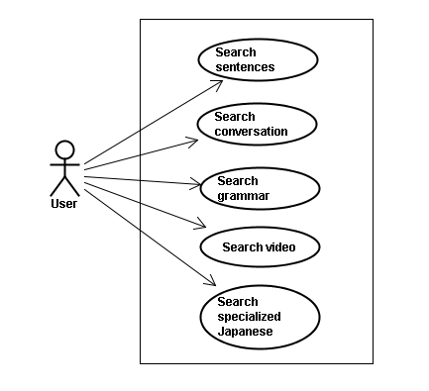

#### スクリーン•デスクリプション

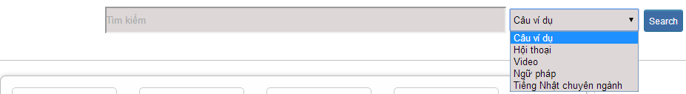

Figure 1: Search

Table 1: Search’s screen description:

|  |  |  |  |  |  |  |  |
| --- | --- | --- | --- | --- | --- | --- | --- |
| No | Field name | Field name in Vietnamese | Type | Require | Mandatory | Length | Description |
| 1 | Searcharea | Tìm kiếm | Text | Text | Y | 255 | User input a new word with length less than 255 characters |
| 2 | SearchOption | Kiểu tìm kiếm | Drop-down list | Click | Y |  | User choose type of search |
| 2 | Search | Search | Button | Click | Y |  | User click on search button |

#### 使用書例仕様

##### UC001: <Common module> Search sentences

|  |  |  |  |  |
| --- | --- | --- | --- | --- |
| **UC001 – Search sentences** | | | | |
| **Use-case No.** | <UC001> | **Use-case Version** | | <1.0> |
| **Use-case Name** | Search sentences | | | |
| **Author** | Tuan NN | | | |
| **Date** | 09/06/2014 | **Priority** | <High > | |
| **Actor:**  Guest, Member, Administrator  **Summary:**  When Guest, Member, Administrator want to search by sentences in database successfully if it is existed  **Triggers**  Click on search area , input sentences in the text area, choose type of search and then click “Search” button  **Preconditions:**   * Website is available * User have to input data in search area   **Post Conditions:**  Display detail information of sentences  **Main Success Scenario:**   |  |  |  | | --- | --- | --- | | **Step** | **User** | **System** | | 1 | Enter website link on web browser | Display Home page screen | | 2 | Input data in search area and choose “Câu ví dụ” type then click button Search | Display “sentences information” screen that contains the information of chosen sentences with these elements:   * Serial number * Name of sentences by hiragana * Name of sentences by romaji * Meaning of sentences |     **Alternative Scenario:**   |  |  |  | | --- | --- | --- | | **At Step** | **User** | **System** | | 2 | Input data in search area and choose “Câu ví dụ” type then click on another link | Switch to selected page |   **Exceptions:**   |  |  |  | | --- | --- | --- | | **At Step** | **User** | **System** | | 2 | Fill data that they want to find (that do not exist in database) into these fields then click “Search” button | Return Error message to inorm that sentences cannot be found | | | | | |

##### UC002: <Common module> Search conversation

|  |  |  |  |  |
| --- | --- | --- | --- | --- |
| **UC002 – Search conversation** | | | | |
| **Use-case No.** | <UC002> | **Use-case Version** | | <1.0> |
| **Use-case Name** | Search conversation | | | |
| **Author** | Tuan NN | | | |
| **Date** | 09/06/2014 | **Priority** | <High > | |
| **Actor:**  Guest, Member, Administrator  **Summary:**  When Guest, Member, Administrator want to search by conversation in database successfully if it is existed  **Triggers**  Click on search area , input conversation in the text area, choose type of search and then click “Search” button  **Preconditions:**   * Website is available * User have to input data in search area   **Post Conditions:**  Display detail information of conversation  **Main Success Scenario:**   |  |  |  | | --- | --- | --- | | **Step** | **User** | **System** | | 1 | Enter website link on web browser | Display Home page screen | | 2 | Input data in search area and choose “Hội thoại” type then click button Search | Display “conversation information” screen that contains the information of chosen conversation with these elements:   * Serial number * Name of conversation by hiragana * Name of conversation by romaji * Meaning of conversation |     **Alternative Scenario:**   |  |  |  | | --- | --- | --- | | **At Step** | **User** | **System** | | 2 | Input data in search area and choose “Hội thoại” type then click on another link | Switch to selected page |   **Exceptions:**   |  |  |  | | --- | --- | --- | | **At Step** | **User** | **System** | | 2 | Fill data that they want to find (that do not exist in database) into these fields then click “Search” button | Return Error message to inform that conversation cannot be found | | | | | |

##### UC003: <Common module> Search grammar

|  |  |  |  |  |
| --- | --- | --- | --- | --- |
| **UC003 – Search grammar** | | | | |
| **Use-case No.** | <UC003> | **Use-case Version** | | <1.0> |
| **Use-case Name** | Search grammar | | | |
| **Author** | Tuan NN | | | |
| **Date** | 09/06/2014 | **Priority** | <High > | |
| **Actor:**  Guest, Member, Administrator  **Summary:**  When Guest, Member, Administrator want to search by grammar in database successfully if it is existed  **Triggers**  Click on search area , input grammar in the text area, choose type of search and then click “Search” button  **Preconditions:**   * Website is available * User have to input data in search area   **Post Conditions:**  Display detail information of grammar  **Main Success Scenario:**   |  |  |  | | --- | --- | --- | | **Step** | **User** | **System** | | 1 | Enter website link on web browser | Display Home page screen | | 2 | Input data in search area and choose “Ngữ pháp” type then click button Search | Display “grammar information” screen that contains the information of chosen grammar with these elements:   * Serial number * Name of grammar by hiragana * Name of grammar by romaji * Meaning of grammar |     **Alternative Scenario:**   |  |  |  | | --- | --- | --- | | **At Step** | **User** | **System** | | 2 | Input data in search area and choose “Ngữ pháp” type then click on another link | Switch to selected page |   **Exceptions:**   |  |  |  | | --- | --- | --- | | **At Step** | **User** | **System** | | 2 | Fill data that they want to find (that do not exist in database) into these fields then click “Search” button | Return Error message to inform that grammar cannot be found | | | | | |

##### UC004: <Common module> Search video

|  |  |  |  |  |
| --- | --- | --- | --- | --- |
| **UC004 – Search video** | | | | |
| **Use-case No.** | <UC004> | **Use-case Version** | | <1.0> |
| **Use-case Name** | Search video | | | |
| **Author** | Tuan NN | | | |
| **Date** | 09/06/2014 | **Priority** | <High > | |
| **Actor:**  Guest, Member, Administrator  **Summary:**  When Guest, Member, Administrator want to search by video in database successfully if it is existed  **Triggers**  Click on search area , input video in the text area, choose type of search and then click “Search” button  **Preconditions:**   * Website is available * User have to input data in search area   **Post Conditions:**  Display detail information of video  **Main Success Scenario:**   |  |  |  | | --- | --- | --- | | **Step** | **User** | **System** | | 1 | Enter website link on web browser | Display Home page screen | | 2 | Input data in search area and choose “Video” type then click button Search | Display “video information” screen that contains the information of chosen video with these elements:   * Serial number * Name of video by hiragana * Name of video by romaji * Meaning of video |     **Alternative Scenario:**   |  |  |  | | --- | --- | --- | | **At Step** | **User** | **System** | | 2 | Input data in search area and choose “Video” type then click on another link | Switch to selected page |   **Exceptions:**   |  |  |  | | --- | --- | --- | | **At Step** | **User** | **System** | | 2 | Fill data that they want to find (that do not exist in database) into these fields then click “Search” button | Return Error message to inform that video cannot be found | | | | | |

##### UC005: <Common module> Search specialized Japanese

|  |  |  |  |  |
| --- | --- | --- | --- | --- |
| **UC005 – Search specialized Japanese** | | | | |
| **Use-case No.** | <UC005> | **Use-case Version** | | <1.0> |
| **Use-case Name** | Search specialized Japanese | | | |
| **Author** | Tuan NN | | | |
| **Date** | 09/06/2014 | **Priority** | <High > | |
| **Actor:**  Guest, Member, Administrator  **Summary:**  When Guest, Member, Administrator want to search by specialized Japanese in database successfully if it is existed  **Triggers**  Click on search area , input specialized Japanese in the text area, choose type of search and then click “Search” button  **Preconditions:**   * Website is available * User have to input data in search area   **Post Conditions:**  Display detail information of video  **Main Success Scenario:**   |  |  |  | | --- | --- | --- | | **Step** | **User** | **System** | | 1 | Enter website link on web browser | Display Home page screen | | 2 | Input data in search area and choose “Tiếng Nhật chuyên ngành” type then click button Search | Display “specialized Japanese information” screen that contains the information of chosen specialized Japanese with these elements:   * Serial number * Name of specialized Japanese by hiragana * Name of specialized Japanese by romaji * Meaning of specialized Japanese |     **Alternative Scenario:**   |  |  |  | | --- | --- | --- | | **At Step** | **User** | **System** | | 2 | Input data in search area and choose “Tiếng Nhật chuyên ngành” type then click on another link | Switch to selected page |   **Exceptions:**   |  |  |  | | --- | --- | --- | | **At Step** | **User** | **System** | | 2 | Fill data that they want to find (that do not exist in database) into these fields then click “Search” button | Return Error message to inform that specialized Japanese cannot be found | | | | | |

### アカウント•マネージメント•モジュール

#### 使用事例図表

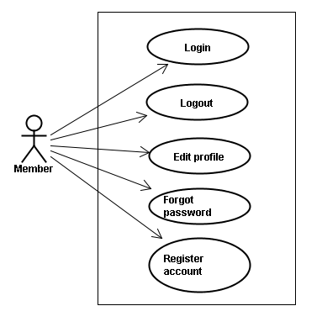

#### 使用書例仕様

##### UC006: <Account management module> Login



Figure 2.1: Login

Table 2.1: Login’s screen description:

|  |  |  |  |  |  |  |  |
| --- | --- | --- | --- | --- | --- | --- | --- |
| No | Field name | Field name in Vietnamese | Type | Require | Mandatory | Max-Length | Description |
| 1 | Username | Tên đăng nhập | Text | Text | Y | 32 | User input username with length less than 32 character |
| 2 | Password | Mật khẩu | Password | Text | Y | 32 | User input their password with length less than 32 characters |
| 3 | Login | Đăng nhập | Button | Click | Y |  | User click on Login button |

|  |  |  |  |  |
| --- | --- | --- | --- | --- |
| **UC006 – Login** | | | | |
| **Use-case No.** | <UC006> | **Use-case Version** | | <1.0> |
| **Use-case Name** | Login | | | |
| **Author** | Tuan NN | | | |
| **Date** | 09/06/2014 | **Priority** | <High > | |
| **Actor:**  Member, Administrator  **Summary:**  When Member, Administrator want to login by Facebook/Google/Register account to use more functions in website  **Triggers**  User choose the login method, input data and click on login button  **Preconditions:**   * Website is available * Account Facebook/Google/Register must be exist and correctly   **Post Conditions:**  Login successfully and redirect user to previous page.  **Main Success Scenario:**   |  |  |  | | --- | --- | --- | | **Step** | **User** | **System** | | 1 | Enter website link on web browser | Display Homepage screen | | 2 | Choose login method ( login by Facebook/Google/register account), input account and password and then click “Đăng nhập” button | Validate information and log user into system. |     **Alternative Scenario:**   |  |  |  | | --- | --- | --- | | **At Step** | **User** | **System** | | 2 | Input data in username and password area then click on another link | Switch to selected page |   **Exceptions:**   |  |  |  | | --- | --- | --- | | **At Step** | **User** | **System** | | 3 | Fill incorrect or missing information “Tên đăng nhập”/ “Mật khẩu” field | Return Error message beside “Tên đăng nhập”/ “Mật khẩu” field. | | | | | |

##### UC007: <Account management module> Logout

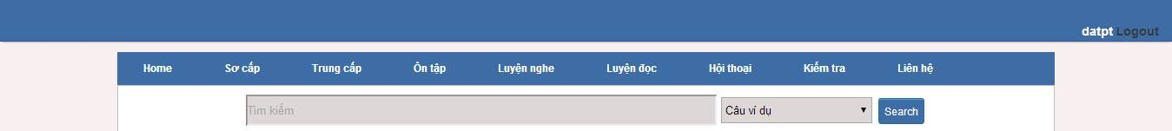

Figure 2.2: Logout

Table 2.2: Logout’s screen description:

|  |  |  |  |  |  |  |
| --- | --- | --- | --- | --- | --- | --- |
| No | Field name | Type | Require | Mandatory | Max-Length | Description |
| 1 | Logout | Button | Click | Y |  | User click on Logout button |

|  |  |  |  |  |
| --- | --- | --- | --- | --- |
| **UC007 – Logout** | | | | |
| **Use-case No.** | <UC007> | **Use-case Version** | | <1.0> |
| **Use-case Name** | Logout | | | |
| **Author** | Tuan NN | | | |
| **Date** | 09/06/2014 | **Priority** | <High > | |
| **Actor:**  Member, Admin  **Summary:**  When Member, Admin want to logout their account  **Triggers**  Click on logout button  **Preconditions:**   * Website is available * Member, Admin must be login   **Post Conditions:**  Redirect user to previous page.  **Main Success Scenario:**   |  |  |  | | --- | --- | --- | | **Step** | **User** | **System** | | 1 | Click on logout button | Redirect to homepage | | | | | |

##### UC008: <Account management Module>: Register account

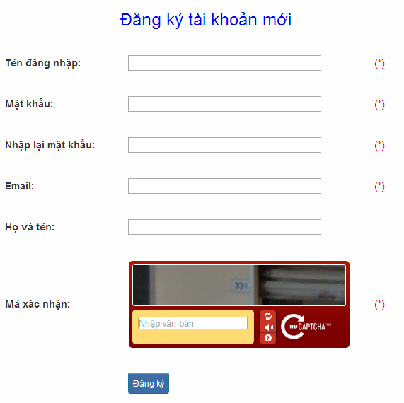

Figure 2.3: Register

Table 2.3: Register’s screen description:

|  |  |  |  |  |  |  |  |
| --- | --- | --- | --- | --- | --- | --- | --- |
| No | Field name | Field name in Vietnamese | Type | Require | Mandatory | Max-Length | Description |
| 1 | Username | Tên đăng nhập | Text | Text | Y | 32 | User input username with length less than 32 characters |
| 2 | Password | Mật khẩu | Password | Text | Y | 32 | User input their password with length less than 32 characters |
| 3 | Re-password | Nhập lại mật khẩu | Password | Text | Y | 32 | User re-input password with length less than 32 characters |
| 4 | Name | Họ và tên | Text | Text | Y | 50 | User input their name with length less than 50 characters |
| 5 | Email | Email | Text | Text | Y | 100 | User input email with length less than 32 characters |
| 6 | Capcha | Mã xác nhận | Text | Text | Y | 100 | User input the verification code |
| 7 | Register | Đăng ký | Button | Click | Y |  | User click Register button |

|  |  |  |  |  |
| --- | --- | --- | --- | --- |
| **UC008 – Register account** | | | | |
| **Use-case No.** | <UC008> | **Use-case Version** | | <1.0> |
| **Use-case Name** | Register | | | |
| **Author** | Tuan NN | | | |
| **Date** | 09/06/2014 | **Priority** | <High > | |
| **Actor:**  Guest  **Summary:**  Visitor can create new account to use more function as a register user  **Triggers**  Click on register link on the website  **Preconditions:**   * Website is available   **Post Conditions:**  Create account for guest  **Main Success Scenario:**   |  |  |  | | --- | --- | --- | | **Step** | **User** | **System** | | 1 | Enter website link on web browser | Display Homepage screen | | 2 | Click on register link | Display register form | | 3 | Enter necessary and mandatory information and click "Đăng kí" button. | Display message to register successfully and redirect to homepage |     **Alternative Scenario:**   |  |  |  | | --- | --- | --- | | **At Step** | **User** | **System** | | 3 | Enter necessary and mandatory information and click another link | Switch to selected page |   **Exceptions:**   |  |  |  | | --- | --- | --- | | **At Step** | **User** | **System** | | 3 | Missing “Tên đăng nhập” field and click “Đăng kí” button | Display error message beside “Tên đăng nhập” field. | | 3 | Enter incorrect information or missing “Mật khẩu” field and click “Đăng kí” button | Display error message beside “Mật khẩu” field. | | 3 | Missing “Họ và tên” field and click “Đăng kí” button | Display error message beside “Họ và tên” field. | | 3 | Missing “Email” field and click “Đăng kí” button | Display error message eside “Email” field. | | 3 | Enter incorrect information or missing “Mã xác nhận” field and click “Đăng kí” button | Display error message beside “Mã xác nhận” field. | | | | | |

##### UC009: <Account management Module>: Edit profile

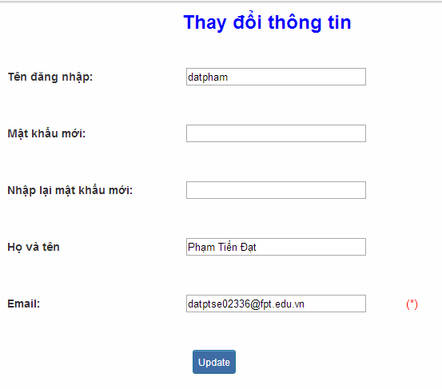

Figure 2.4: Edit profile

Table 2.4: Edit profile’s screen description:

|  |  |  |  |  |  |  |  |
| --- | --- | --- | --- | --- | --- | --- | --- |
| No | Field name | Field name in Vietnamese | Type | Require | Mandatory | Max-Length | Description |
| 1 | Name | Họ và tên | Text | Text | Y | 32 | User input their name with length less than 32 characters |
| 2 | Old-Password | Mật khẩu cũ | Password | Text | Y | 32 | User input their old password with length less than 32 characters |
| 3 | New-password | Mật khẩu mới | Password | Text | Y | 32 | User input new password with length less than 32 characters |
| 4 | Re-password | Nhập lại mật khẩu mới | Password | Text | Y | 32 | User re-input password with length less than 32 characters |
| 5 | Email | Email | Text | Text | Y | 100 | User input email to with length less than 100 characters |
| 6 | Edit | Thay đổi thông tin | Button | Click | Y |  | User click on Edit button |

|  |  |  |  |  |
| --- | --- | --- | --- | --- |
| **UC009 – Edit profile** | | | | |
| **Use-case No.** | <UC009> | **Use-case Version** | | <1.0> |
| **Use-case Name** | Edit profile | | | |
| **Author** | Tuan NN | | | |
| **Date** | 09/06/2014 | **Priority** | <High > | |
| **Actor:**  Member  **Summary:**  When member want to change their profile  **Triggers**  Login the website and click on the edit profile link  **Preconditions:**   * Website is available * Member login the website   **Post Conditions:**  Edit profile successful and redirect user to edited profile page  **Main Success Scenario:**   |  |  |  | | --- | --- | --- | | **Step** | **User** | **System** | | 1 | Enter website link on web browser | Display Homepage screen | | 2 | Enter necessary and mandatory information and click "Login” | Redirect to previous page and logged user into system. | | 3 | Click on "Trang cá nhân" link. | Display “Trang cá nhân” page | | 4 | User changes profile and click “Lưu” button | Update new profile |     **Alternative Scenario:**   |  |  |  | | --- | --- | --- | | **t Step** | **User** | **System** | | 4 | Enter necessary and mandatory information and click another link | Switch to selected page |   **Exceptions:**   |  |  |  | | --- | --- | --- | | **At Step** | **User** | **System** | | 4 | Enter new password that incorrect form or missing information and click “Lưu” button | Displa ero message | | 4 | Enter new email that incorrect form or missing information and click “Lưu” button | Display error message | | | | | |

##### UC010: <Account management Module>: Forgot password

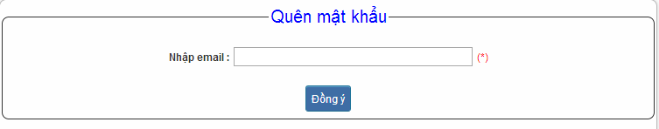

Figure 2.5: Forgot password

Table 2.5: Forgot password’s screen description:

|  |  |  |  |  |  |  |  |
| --- | --- | --- | --- | --- | --- | --- | --- |
| No | Field name | Field name in Vietnamese | Type | Require | Mandatory | Max-Length | Description |
| 1 | Email | Email | Text | Text | Y | 32 | User input email with length less than 100 characters |
| 2 | Send | Đồng ý | Button | Click | Y |  | Click to receive password |

|  |  |  |  |  |
| --- | --- | --- | --- | --- |
| **UC010 – Forgot password** | | | | |
| **Use-case No.** | <UC010> | **Use-case Version** | | <1.0> |
| **Use-case Name** | Forgot password | | | |
| **Author** | Tuan NN | | | |
| **Date** | 09/06/2014 | **Priority** | <High > | |
| **Actor:**  Member, Admin  **Summary:**  When Member, Admin forgot their password to login the system, this function will receiving their password to email  **Triggers**  Click on forgot password link on the website  **Preconditions:**   * Website is available   **Post Conditions:**  Receiving their password to their email  **Main Success Scenario:**   |  |  |  | | --- | --- | --- | | **Step** | **User** | **System** | | 1 | Enter website link on web browser | Display Homepage screen | | 2 | Click on “Quên mật khẩu link. | Display “Quên mật khẩu” page | | 3 | Enter necessary and mandatory information in the “Quên mật khẩu” form and click "Gửi yêu cầu" button. | System will send the password into your emi. |     **Alternative Scenario:**   |  |  |  | | --- | --- | --- | | **At Step** | **User** | **Syste** | | 3 | Enter necessary and mandatory information and click another link | Switch to selected page |   **Exceptions:**   |  |  |  | | --- | --- | --- | | **At Step** | **User** | **System** | | 3 | Enter email incorrect with email that use to register account | Display error message and request to re-enter email | | | | | |

### コンタック•アドミン • モジュール

#### 使用事例図表

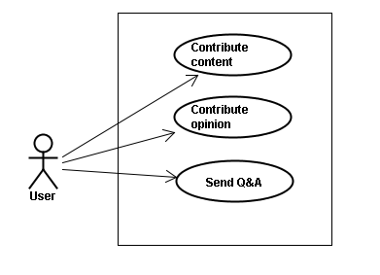

#### 使用書例仕様

##### UC011 <Contact admin Module>: Contribute content

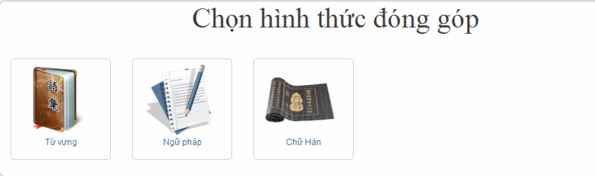

Figure 3.1: Contribute content

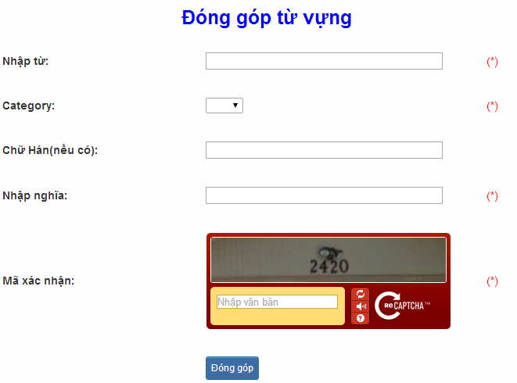

Figure 3.1.1: Contribute vocabulary

Table 3.1: Contribute vocabulary’s screen description:

|  |  |  |  |  |  |  |  |  |  |  |  |  |
| --- | --- | --- | --- | --- | --- | --- | --- | --- | --- | --- | --- | --- |
| No | | Field name | Field name in Vietnamese | | Type | Require | Mandatory | | Max-Length | | Description | |
| 1 | | Vocabulary | Từ | | Text | Text | Y | | 200 | | User input vocabulary with length less than 200 characters | |
| 2 | | Category | Loại từ | | Drop-down list | Click | Y | |  | | User choose type of category | |
| 3 | | Kanji | Chữ Hán | | Text | Text | Y | | 10 | | User input kanji of vocabulary (if exist) with length less than 10 characters | |
| 4 | | Mean | Nhập nghĩa | | Text | Text | Y | | 500 | | User input mean of vocabulary with length less than 500 characters | |
| 5 | | Capcha | Mã xác nhận | | Text | Text | Y | |  | | User input the verification code | |
| 6 | | Contribute | Đóng góp | | Button | Click | Y | |  | | User click on contribute button | |
| **UC011 – Contribute content** | | | | | | | | | | | | |
| **Use-case No.** | | | <UC011> | | | | **Use-case Version** | | | | <1.0> | |
| **Use-case Name** | | | Contribute content | | | | | | | | | |
| **Author** | | | Tuan NN | | | | | | | | | |
| **Date** | | | 09/06/2014 | | | | **Priority** | | <High > | | | |
| **Actor:**  Member  **Summary:**  When Member want to contribute content for website  **Triggers**  User enter website link and click on “Liên hệ” link on the website  **Preconditions:**   * Website is available * User must be login to the website   **Post Conditions:**  Receive opinions and redirect user to contact page  **Main Success Scenario:**   |  |  |  | | --- | --- | --- | | **Step** | **User** | **System** | | 1 | Enter website link on web browser | Display Homepage screen | | 2 | Enter necessary and mandatory information and click "Login” | Redirect to previous page and logged user into system. | | 3 | Click on “Liên hệ”->”Đóng góp database” section | Display “Đóng góp database” page | | 4 | Enter information that member want to contribute for the website then click “Đóng góp” | System will receive contributions |     **Alternative Scenario:**   |  |  |  | | --- | --- | --- | | **At Step** | **User** | **ystem** | | 4 | Enter necessary and mandatory information and click another link | Switch to selected page |   **Exceptions:**   |  |  |  | | --- | --- | --- | | **At Step** | **User** | **System** | | 4 | Missing “Nhập từ” field and click “Đóng góp” button | Display error message beside “Nhập từ” field. | | 4 | Missing “Loại từ” field and click “Đóng góp” button | Display error message beside “Loại từ” field. | | 4 | Missing “Nhập nghĩa” field and click “Đóng góp” button | Display error message beside “Nhập nghĩa” field. | | 4 | Enter incorrect information or missing “Mã xác nhận” field and click “Đóng góp” button | Display error message beside “Mã xác nhận” field. | | | | | | | | | | | | | |

##### UC012 <Contact admin Module>: Contribute opinion

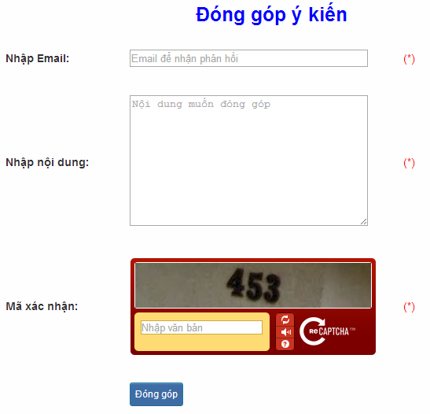

Figure 3.2: Contribute opinion

Table 3.2 : Contribute opinion’s screen description:

|  |  |  |  |  |  |  |  |
| --- | --- | --- | --- | --- | --- | --- | --- |
| No | Field name | Field name in Vietnamese | Type | Require | Mandatory | Max-Length | Description |
| 1 | Email | Email | Text | Text | Y | 100 | User input email with length less than100 characters |
| 2 | Content | Nhập nội dung | Text | Text | Y | 1000 | User input content with length less than1000 characters |
| 3 | Capcha | Mã xác nhận | Text | Text | Y |  | User input the verification code |
| 4 | Contribute | Đóng góp | Button | Click | Y |  | User click on contribute button |

|  |  |  |  |  |
| --- | --- | --- | --- | --- |
| **UC012 – Contribute opinion** | | | | |
| **Use-case No.** | <UC012> | **Use-case Version** | | <1.0> |
| **Use-case Name** | Contribute opinion | | | |
| **Author** | Tuan NN | | | |
| **Date** | 09/06/2014 | **Priority** | <High > | |
| **Actor:**  Member  **Summary:**  When Member want to contribute opinion for website  **Triggers**  User enter website link and click on “Liên hệ” link on the website  **Preconditions:**   * Website is available * User must be login to the website   **Post Conditions:**  Receive opinions and redirect user to contact page  **Main Success Scenario:**   |  |  |  | | --- | --- | --- | | **Step** | **Use** | **System** | | 1 | Enter website link on webbrowser | Display Homepage screen | | 2 | Enter necessary and mandatory information and click "Login” | Redirect to previous page and logged user into system. | | 3 | Click on “Liên hệ”->”Đóng góp ý kiến” section | Display “Đóng góp ý kiến” page | | 4 | Enter information that member want to contribute for the website then click “Đóng góp” | System will receive contributions |   **Alternative Scenario:**   |  |  |  | | --- | --- | --- | | **At Step** | **User** | **System** | | 4 | Enter necessary and mandatory information and click another link | Switch to selected page |   **Exceptions:**   |  |  |  | | --- | --- | --- | | **At Step** | **User** | **System** | | 4 | Missing “Nhập email” field and click “Đóng góp” button | Display error message beside “Nhập email” field. | | 4 | Missing “Nhập nội dung:” field and click “Đóng góp” button | Display error message beside “Nhập nội dung:” field. | | 4 | Enter incorrect information or missing “Mã xác nhận” field and click “Đóng góp” button | Display error message beside “Mã xác nhận” field. | | | | | |

##### UC013 <Contact admin Module>: Send Q&A

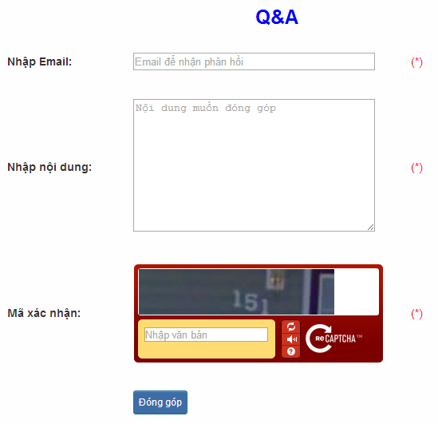

Figure 3.3: Send Q&A

Table 3.3: Send Q&A’s screen description:

|  |  |  |  |  |  |  |  |
| --- | --- | --- | --- | --- | --- | --- | --- |
| No | Field name | Field name in Vietnamese | Type | Require | Mandatory | Max-Length | Description |
| 1 | QA | Q&A | Text | Text | Y | 1000 | User input Q&A with length less than 1000 characters |
| 2 | Email | Email | Text | Text | Y | 100 | User input email with length less than 100 characters |
| 3 | Capcha | Mã xác nhận | Text | Text | Y |  | User input the verification code |
| 4 | Contribute | Đóng góp | Button | Click | Y |  | User click on contribute button |

|  |  |  |  |  |
| --- | --- | --- | --- | --- |
| **UC013 – Send Q&A** | | | | |
| **Use-case No.** | <UC013> | **Use-case Version** | | <1.0> |
| **Use-case Name** | Send Q&A | | | |
| **Author** | Tuan NN | | | |
| **Date** | 09/06/2014 | **Priority** | <High > | |
| **Actor:**  Member  **Summary:**  When Member have the question, they can create Q&A  **Triggers**  Click on “Liên hệ” link on the website  **Preconditions:**   * Website is available * User must be login to the website   **Post Conditions:**  Add new Q&A into the website  **Main Success Scenario:**   |  |  |  | | --- | --- | --- | | **Step** | **User** | **System** | | 1 | Enter website link on web browser | Display Homepage screen | | 2 | Enter necessary and mandatory information and click "Login” | Redirect to previous page and logged user into system. | | 3 | Click on “Q&A” section | Display “Q&A” page | | 4 | Enter necessary and mandatory information in the “Q&A” form and click "Gửi" button. | Display this Q&A in the “Q&A”section. |     **Alternative Scenario:**   |  |  |  | | --- | --- | --- | | **At Step** | **User** | **System** | | 4 | Enter necessary and mandatory information and click another link | Switch to selected page |   **Exceptions:**   |  |  |  | | --- | --- | --- | | **At Step** | **User** | **System** | | 4 | Missing “Nhập email” field and click “Đóng góp” button | Display error message beside “Nhập email” field. | | 4 | Missing “Q&A” field and click “Đóng góp” button | Display error message beside “Q&A” field. | | 4 | Enter incorrect information or missing “Mã xác nhận” field and click “Đóng góp” button | Display error message beside “Mã xác nhận” field. | | | | | |

### プラクティス•マネージメント•モジュール

#### 使用事例図表

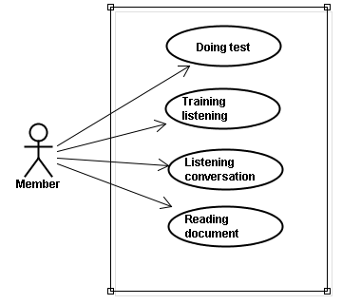

#### 使用書例仕様

##### UC014 <Practice management Module>: Doing test

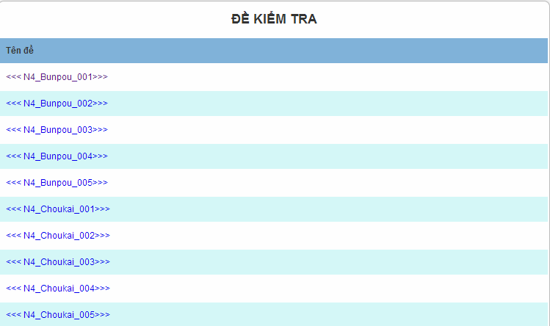

Figure 4.1: Doing test

Screen description: This is doing test screen ( N4 test screen). At here, user can doing test in the website, they click on one of test link

|  |  |  |  |  |
| --- | --- | --- | --- | --- |
| **UC014 – Doing test** | | | | |
| **Use-case No.** | <UC014> | **Use-case Version** | | <1.0> |
| **Use-case Name** | Doing test | | | |
| **Author** | Tuan NN | | | |
| **Date** | 09/06/2014 | **Priority** | <High > | |
| **Actor:**  Member  **Summary:**  This function will help users do the online quiz and check the answers, grading and evaluation capabilities  **Triggers**  User going to website, login and then click on “Kiểm tra” link on the website  **Preconditions:**   * Website is available * User must be login to the website   **Post Conditions:**  Doing test in the website  **Main Success Scenario:**   |  |  |  | | --- | --- | --- | | **Step** | **User** | **System** | | 1 | Enter website link on web browser | Display Homepage screen | | 2 | Enter necessary and mandatory information and click "Login” | Redirect to previous page and logged user into system. | | 3 | Click on “Kiểm tra” section | Display “Kiểm tra” page | | 4 | Choose one of items that you want to doing test | Display that item’s page | | 5 | Doing test | Check the answer, grading after finish |     **Alternative Scenario:**   |  |  |  | | --- | --- | --- | | **At Step** | **User** | **System** | | 5 | While doing test, click another link | Switch to selected page | | | | | |

##### UC015 <Practice management Module>: Trainng listening

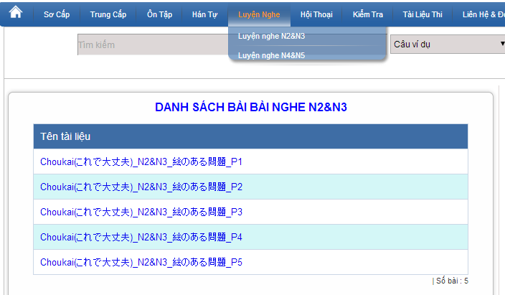

Figure 4.2: Training listening

Screen description:

|  |  |  |  |  |  |  |
| --- | --- | --- | --- | --- | --- | --- |
| No | Field name | Type | Require | Mandatory | Max-Length | Description |
| 1 | Choukai_P1 | Hyperlink | Click | N |  | Display information of listening |
| 2 | Choukai_P2 | Hyperlink | Click | N |  | Display information of listening |
| 3 | Choukai_P3 | Hyperlink | Click | N |  | Display information of listening |
| 4 | Choukai_P4 | Hyperlink | Click | N |  | Display information of listening |
| 5 | Choukai_P5 | Hyperlink | Click | N |  | Display information of listening |

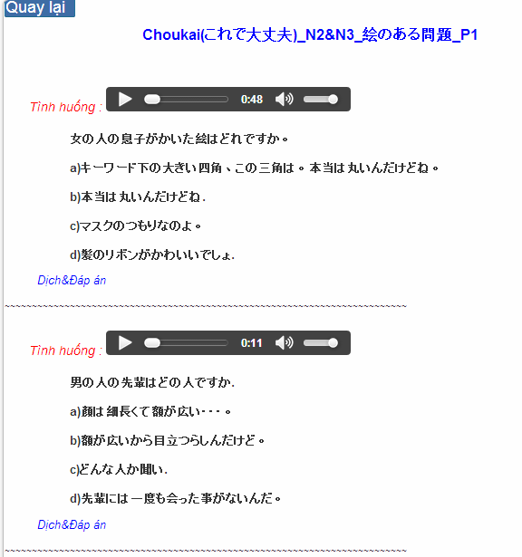

Figure 4.2.1: Training listening content

Table 4.2.1 : Training listening content’s screen description:

|  |  |  |  |  |  |  |
| --- | --- | --- | --- | --- | --- | --- |
| No | Field name | Field name in Vietnamese | Type | Require | Mandatory | Description |
| 1 | Audio | Audio | Audio | Click | Y | User click play button |
| 2 | Translation and Answer | Dịch và đáp án | Link | Click | Y | User click to display translation and answer |

|  |  |  |  |  |
| --- | --- | --- | --- | --- |
| **UC015 – Training listening** | | | | |
| **Use-case No.** | <UC015> | **Use-case Version** | | <1.0> |
| **Use-case Name** | Training listening | | | |
| **Author** | Tuan NN | | | |
| **Date** | 09/06/2014 | **Priority** | <High > | |
| **Actor:**  Guest, Member  **Summary:**  This function provide users some the listening of level N2, N3, N4 to help users training listening skill  **Triggers**  User going to website and click on “Luyện nghe” link on the website  **Preconditions:**   * Website is available   **Post Conditions:**  Training listening in the website  **Main Success Scenario:**   |  |  |  | | --- | --- | --- | | **Step** | **User** | **System** | | 1 | Enter website link on web browser | Display Homepage screen | | 2 | Click on “Luyện nghe” section | Display “Luyện nghe” page |     **Alternative Scenario:**   |  |  |  | | --- | --- | --- | | **At Stp** | **User** | **System** | | 4 | While listening, click another link | Switch to selected page | | | | | |

##### UC016 <Practice management Module>: Listening conversation

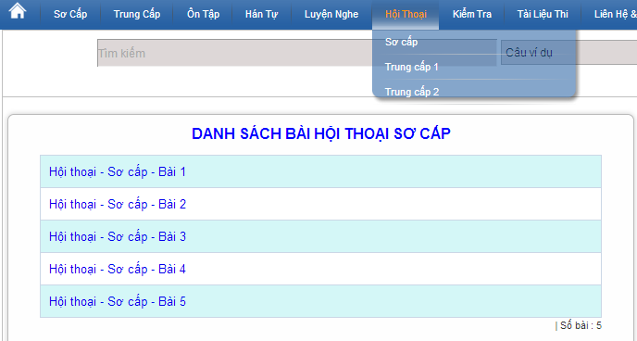

Figure 4.3: Listening conversation

Screen description:

|  |  |  |  |  |  |
| --- | --- | --- | --- | --- | --- |
| No | Field name | Type | Require | Mandatory | Description |
| 1 | SC_P1 | Hyperlink | Click | N | Display information of conversation |
| 2 | SC_P2 | Hyperlink | Click | N | Display information of conversation |
| 3 | SC_P3 | Hyperlink | Click | N | Display information of conversation |
| 4 | SC_P4 | Hyperlink | Click | N | Display information of conversation |
| 5 | SC_P5 | Hyperlink | Click | N | Display information of conversation |

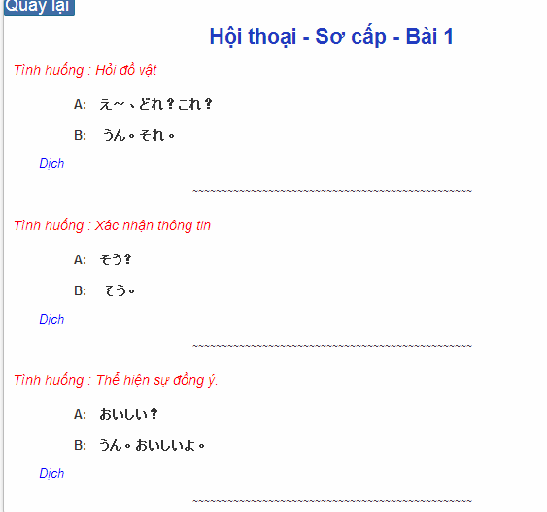

Figure 4.3.1: Conversation content

Table 4.2.1 : Training listening content’s screen description:

|  |  |  |  |  |  |  |
| --- | --- | --- | --- | --- | --- | --- |
| No | Field name | Field name in Vietnamese | Type | Require | Mandatory | Description |
| 1 | Translation | Dịch | Link | Click | Y | User click to display translation |

|  |  |  |  |  |
| --- | --- | --- | --- | --- |
| **UC016 – Listening conversation** | | | | |
| **Use-case No.** | <UC016> | **Use-case Version** | | <1.0> |
| **Use-case Name** | Listening conversation | | | |
| **Author** | Tuan NN | | | |
| **Date** | 09/06/2014 | **Priority** | <High > | |
| **Actor:**  Guest, Member  **Summary:**  This function provide users some the conversation in everyday life and common situations (eg: restaurants, shopping, in hospital ..)  **Triggers**  Click on “Hội thoại” link on the website  **Preconditions:**   * Website is available   **Post Conditions:**  Listening conversation in the website  **Main Success Scenario:**   |  |  |  | | --- | --- | --- | | **Step** | **User** | **System** | | 1 | Enter websie link n web browser | Display Homepage screen | | 2 | Click on “Hội thoại” section | Display “Hội thoại” page |     **Alternative Scenario:**   |  |  |  | | --- | --- | --- | | **At Step** | **User** | **System** | | 4 | While listening, click another link | Switch to selected page | | | | | |

##### UC017 < Practice management Module>: Reading document

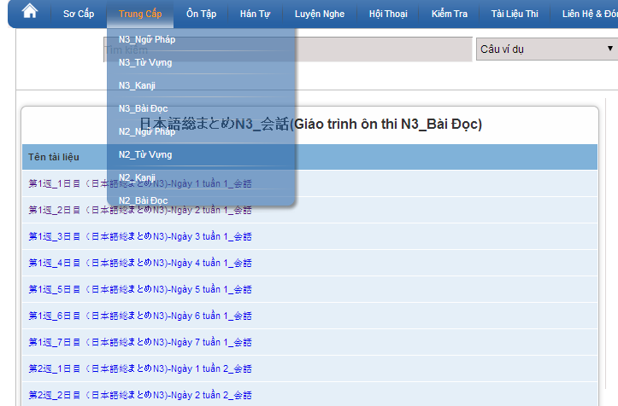

Figure 4.4: Reading document

Screen description: This is reading screen. At here, user can read document in the website, there are some lesson to reading in the reading document.

|  |  |  |  |  |
| --- | --- | --- | --- | --- |
| **UC017 – Reading document** | | | | |
| **Use-case No.** | <UC017> | **Use-case Version** | | <1.0> |
| **Use-case Name** | Reading document | | | |
| **Author** | Tuan NN | | | |
| **Date** | 09/06/2014 | **Priority** | <High > | |
| **Actor:**  Guest, Member  **Summary:**  This function provide users some document : elementary, intermediate and review.  **Triggers**  Click on “N3/N2 Bài đọc” link on the website  **Preconditions:**   * Website is available   **Post Conditions:**  Reading document in the website  **Main Success Scenario:**   |  |  |  | | --- | --- | --- | | **Step** | **User** | **System** | | 1 | Enter website link on web browser | Display Homepage screen | | 2 | Click on “Bài đọc” section | Display “Bài đọc” page |     **Alternative Scenario:**   |  |  |  | | --- | --- | --- | | **At Step** | **User** | **System** | | 4 | While reading, click another link | Switch to selected page | | | | | |

### アドミンアカウント•マネージメント

#### 使用事例図表

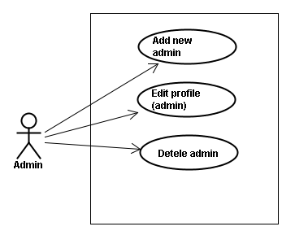

#### 使用書例仕様

##### UC018 <Admin’s account management>: Add new admin

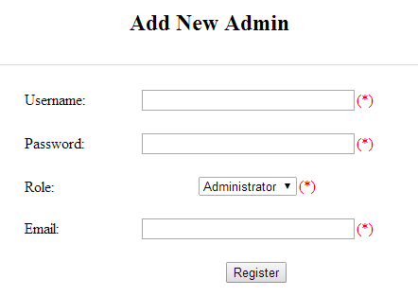

Figure 5.1: Add new admin

Table 5.1: Add new admin’s screen description:

|  |  |  |  |  |  |  |
| --- | --- | --- | --- | --- | --- | --- |
| No | Field name | Type | Require | Mandatory | Max-Length | Description |
| 1 | Username | Text | Text | Y | 32 | Admin input username of admin’s account with length less than 32 characters |
| 2 | Password | Text | Text | Y | 100 | Admin input password of admin’s account with length less than 32 characters |
| 3 | Roll | Drop-down list | Choose | Y |  | Admin choose the roll of account |
| 4 | Email | Text | Text | Y | 100 | Admin input email of admin’s account with length less than 100 characters |
| 5 | Register | Button | Click | Y |  | Admin add new admin |

|  |  |  |  |  |
| --- | --- | --- | --- | --- |
| **UC018 – Add new admin** | | | | |
| **Use-case No.** | <UC018> | **Use-case Version** | | <1.0> |
| **Use-case Name** | Add new admin | | | |
| **Author** | Tuan NN | | | |
| **Date** | 09/06/2014 | **Priority** | <High > | |
| **Actor:**  Admin  **Summary:**  Administrator can add new admin  **Triggers**  Admin login the website and click on add new admin link on the website  **Preconditions:**   * Website is available * Admin login to the website   **Post Conditions:**  New admin be added successfully  **Main Success Scenario:**   |  |  |  | | --- | --- | --- | | **Step** | **User** | **System** | | 1 | Enter website link on web browser | Display Homepage screen | | 2 | Enter necessary and mandatory information and click "Login” | Redirect to previous page and logged admin into system. | | 3 | Click on add new admin button | Display “Add New Admin” screen that contains these elements:   * Username * Password * Roll * Email | | 4 | Fill test information into all necessary or mandatory fields and click “Add” button | The system validates the input data and then save new test data into database |     **Alternative Scenario:**   |  |  |  | | --- | --- | --- | | **At Step** | **User** | **System** | | 4 | Input data in account area then click on another link | Switch to selected page |   **Exceptions:**   |  |  |  | | --- | --- | --- | | **At Step** | **User** | **System** | | 4 | Fill incorrect account name | Return Error message | | | | | |

##### UC019 <Admin’s account management>: Edit profile (admin)

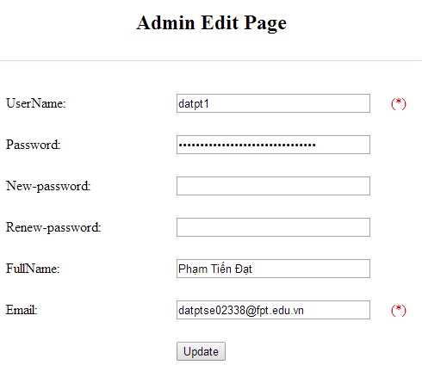

Figure 5.2: Edit profile admin

Table 5.2: Edit profile admin’s screen description:

|  |  |  |  |  |  |  |
| --- | --- | --- | --- | --- | --- | --- |
| No | Field name | Type | Require | Mandatory | Max-Length | Description |
| 1 | Username | Text | Text | N |  | Username of admin’s account |
| 2 | New-password | Text | Text | Y | 32 | Admin input new password with length less than 32 characters |
| 3 | Renew-password | Text | Text | Y | 32 | Admin re-input new password with length less than 32 characters |
| 4 | Fullname | Text | Text | Y | 100 | Admin input full name with length less than 100 characters |
| 5 | Email | Text | Text | Y | 100 | Admin input email with length less than 100 characters |
| 6 | Update | Button | Click | Y |  | User click to edit vocabulary |

|  |  |  |  |  |
| --- | --- | --- | --- | --- |
| **UC019 – Edit profile(admin)** | | | | |
| **Use-case No.** | <UC019> | **Use-case Version** | | <1.0> |
| **Use-case Name** | Edit profile admin | | | |
| **Author** | Tuan NN | | | |
| **Date** | 09/06/2014 | **Priority** | <High > | |
| **Actor:**  Administrator  **Summary:**  Administrator want to change their profile  **Triggers**  Administrator login the website and click on the edit profile link  **Preconditions:**   * Website is available * Administrator login the website   **Post Conditions:**  Edit admin profile and redirect to edited profile page  **Main Success Scenario:**   |  |  |  | | --- | --- | --- | | **Step** | **User** | **System** | | 1 | Enter website link on web browser | Display Homepage screen | | 2 | Enter necessary and mandatory information and click "Login” | Redirect to previous page and logged admin into system. | | 3 | Click on edit profile tab | Display “Edit profile” screen that contains these elements:   * Username * Password * New-Password * Renew-Password * Full name * Email | | 4 | Fill test information into all necessary or mandatory fields and click “Add” button | The system validates the input data and then save new test data into database |   **Alternative Scenario:**   |  |  |  | | --- | --- | --- | | **At Step** | **User** | **System** | | 4 | Enter necessary and mandatory information and click another link | Switch to selected page |   **Exceptions:**   |  |  |  | | --- | --- | --- | | **At Step** | **User** | **System** | | 4 | Enter new password that incorrect form or missing information and click “Lưu” button | Display error message | | 4 | Enter new email that incorrect form or missing information and click “Lưu” button | Display error message | | | | | |

##### UC020 <Admin’s account management>: Delete admin

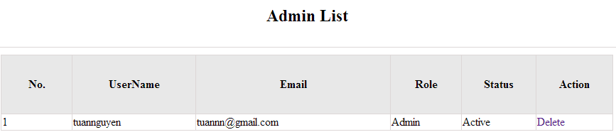

Figure 5.3: Delete admin

|  |  |  |  |  |
| --- | --- | --- | --- | --- |
| **UC020 – Delete admin** | | | | |
| **Use-case No.** | <UC020> | **Use-case Version** | | <1.0> |
| **Use-case Name** | Delete admin | | | |
| **Author** | Tuan NN | | | |
| **Date** | 09/06/2014 | **Priority** | <High > | |
| **Actor:**  Administrator  **Summary:**  Administrators can remove administrator rights of other admin  **Triggers**  Login the website and click on the delete admin link  **Preconditions:**   * Website is available * Admin login the website   **Post Conditions:**  Admin will be remove administrator rights  **Main Success Scenario:**   |  |  |  | | --- | --- | --- | | **Step** | **User** | **System** | | 1 | Enter website link on web browser | Display Homepage screen | | 2 | Enter necessary and mandatory information and click "Login” | Redirect to previous page and logged admin into system. | | 3 | Click on delete admin link. | Display delete admin page | | 4 | Enter the account that you want to remove administrator rights | Remove administrator rights of account and display message to remove successfully |     **Alternative Scenario:**   |  |  |  | | --- | --- | --- | | **At Step** | **User** | **System** | | 4 | Input data in account area then click on another link | Switch to selected page |   **Exceptions:**   |  |  |  | | --- | --- | --- | | **At Step** | **User** | **System** | | 4 | Fill incorrect account name | Return Error message | | | | | |

### メンバーアカウント•マネージメント

#### 使用事例図表

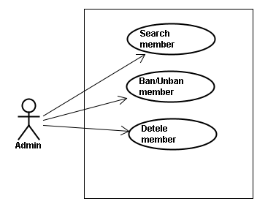

#### スクリーン•デスクリプション

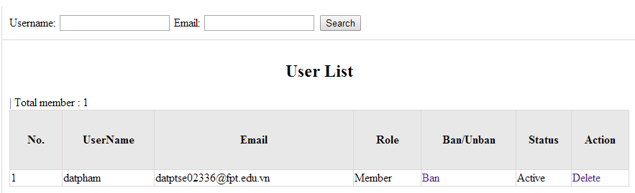

Figure 6: Management Member

Table 6: Management member’s screen description:

|  |  |  |  |  |  |  |
| --- | --- | --- | --- | --- | --- | --- |
| No | Field name | Type | Require | Mandatory | Max-Length | Description |
| 1 | Username | Text | Text | Y | 32 | Admin input username to search member by username |
| 2 | Email | Text | Text | Y | 100 | Admin input email to search member by email |
| 3 | Ban/Unban | Button | Click | N |  | Admin click ban/unban member |
| 4 | Delete | Button | Click | N |  | Admin click delete member |

#### 使用書例仕様

##### UC021 <Management Member’s account>: Search member

Search member screen:

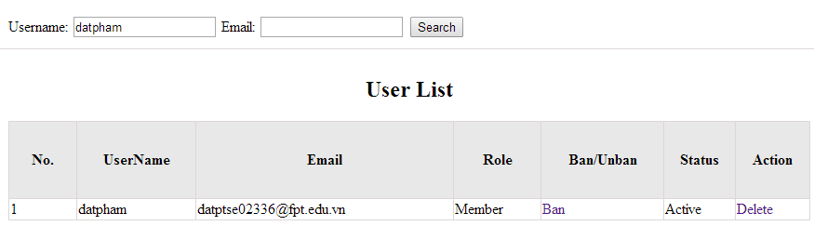

|  |  |  |  |  |
| --- | --- | --- | --- | --- |
| **UC021 – Search member** | | | | |
| **Use-case No.** | <UC021> | **Use-case Version** | | <1.0> |
| **Use-case Name** | Search member | | | |
| **Author** | Tuan NN | | | |
| **Date** | 09/06/2014 | **Priority** | <High > | |
| **Actor:**  Admin  **Summary:**  When admin want to search by member’s account in database successfully if it is existed  **Triggers**  Admin login the website and click on search member , input member’s account in the right text box then click “Search” button  **Preconditions:**   * Website is available * Admin must be login * Input data must be correctly   **Post Conditions:**  Display detail information of member  **Main Success Scenario:**   |  |  |  | | --- | --- | --- | | **Step** | **User** | **System** | | 1 | Enter website link on web browser | Display Homepage screen | | 2 | Enter necessary and mandatory information and click "Login” | Redirect to previous page and logged admin into system. | | 3 | Click on "Search member" button and input member’s account or email | Display “member information” screen that contains the information :   * No * User Name * Email * Roll * Ban/Unban * Status * Delete |     **Alternative Scenario:**   |  |  |  | | --- | --- | --- | | **At Step** | **User** | **System** | | 3 | Fill information of the member that they want to find into these fields then click on another link | Switch to selected page |   **Exceptions:**   |  |  |  | | --- | --- | --- | | **At Step** | **User** | **System** | | 3 | Fill information of the member that they want to find (that do not exist in database) into these fields then click “Search” button | Return Error message to inform that member cannot be found | | | | | |

##### UC022 <Management Member’s account>: Ban/Unban member

|  |  |  |  |  |
| --- | --- | --- | --- | --- |
| **UC022 – Search member** | | | | |
| **Use-case No.** | <UC022> | **Use-case Version** | | <1.0> |
| **Use-case Name** | Ban/Unban member | | | |
| **Author** | Tuan NN | | | |
| **Date** | 09/06/2014 | **Priority** | <High > | |
| **Actor:**  Admin  **Summary:**  When admin can ban user who violated rule of website and unban member  **Triggers**  Admin login the website and click on member’s account and then click “Ban/Unban” button  **Preconditions:**   * Website is available * Admin must be login * Input data must be correctly   **Post Conditions:**  Member’s account will be ban/unban by administrator  **Main Success Scenario:**   |  |  |  | | --- | --- | --- | | **Step** | **User** | **System** | | 1 | Enter website link on web browser | Display Homepage screen | | 2 | Enter necessary and mandatory information and click "Login” | Redirect to previous page and logged admin into system. | | 3 | Click on "Search member" button and input member’s account or email | Display “member information” screen that contains the information | | 4 | Click “Ban/Unban” link | Ban/Unban member |   **Alternative Scenario:**   |  |  |  | | --- | --- | --- | | **At Step** | **User** | **System** | | 3 | Fill information of the member that they want to find into these fields then click on another link | Switch to selected page |   **Exceptions:**   |  |  |  | | --- | --- | --- | | **At Step** | **User** | **System** | | 3 | Fill information of the member that they want to find (that do not exist in database) into these fields then click “Search” button | Return Error message to inform that member cannot be found | | | | | |

##### UC023 <Management Member’s account>: Delete member

|  |  |  |  |  |
| --- | --- | --- | --- | --- |
| **UC023 – Delete member** | | | | |
| **Use-case No.** | <UC023> | **Use-case Version** | | <1.0> |
| **Use-case Name** | Delete member | | | |
| **Author** | Tuan NN | | | |
| **Date** | 09/06/2014 | **Priority** | <High > | |
| **Actor:**  Admin  **Summary:**  Administrators can delete member who violated rule of website  **Triggers**  Admin login the website and click on the delete member link  **Preconditions:**   * Website is available * Admin must be login * Input data must be correctly   **Post Conditions:**  Member’s account will be removed from system  **Main Success Scenario:**   |  |  |  | | --- | --- | --- | | **Step** | **User** | **System** | | 1 | Enter website link on web browser | Display Homepage screen | | 2 | Enter necessary and mandatory information and click "Login” | Redirect to previous page and logged admin into system. | | 3 | Click on "Search member" button and input member’s account or email | Display information of member | | 4 | Click on delete link corresponding with member want to delete | Remove member from list |     **Alternative Scenario:**   |  |  |  | | --- | --- | --- | | **At Step** | **User** | **System** | | 3 | Fill information of the member that they want to find into these fields then click on another link | Switch to selected page |   **Exceptions:**   |  |  |  | | --- | --- | --- | | **At Step** | **User** | **System** | | 3 | Fill information of the member that they want to find (that do not exist in database) into these fields then click “Search” button | Return Error message to inform that member cannot be found | | | | | |

### 言葉•マネージメント

#### 使用事例図表

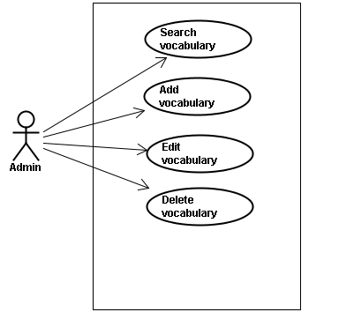

#### スクリーン•デスクリプション

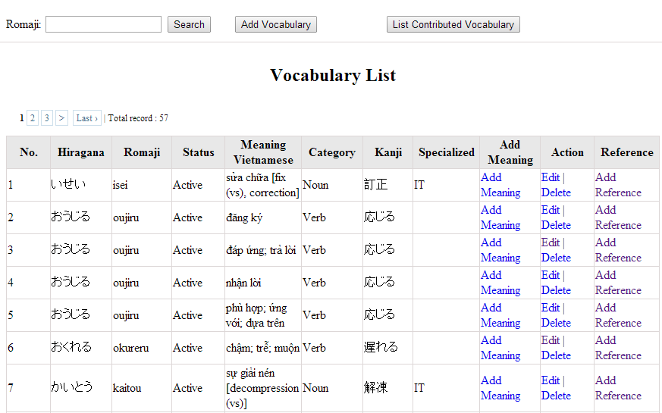

Figure 7: Vocabulary management

Table 7.1: Vocabulary management’s screen description:

|  |  |  |  |  |  |  |
| --- | --- | --- | --- | --- | --- | --- |
| No | Field name | Type | Require | Mandatory | Max-Length | Description |
| 1 | Romaji | Text | Text | Y | 100 | Admin input romaji with length less than 100 character |
| 2 | Search | Button | Click | Y |  | Admin click to search vocabulary |
| 2 | Add-new | Button | Click | N |  | Admin add new vocabulary into database |
| 3 | Add meaning | Button | Click | Y |  | Admin add meaning of vocabulary |
| 4 | Edit | Button | Click | N |  | Admin click edit vocabulary |
| 5 | Delete | Button | Click | N |  | Admin click delete vocabulary |
| 6 | Add-reference | Button | Click | N |  | Admin add reference of vocabulary if reference exist |
| 7 | List-contribute | Button | Click | N |  | Admin click to view list contribute |

#### 使用書例仕様

##### UC024 <Vocabulary Management>: Search vocabulary

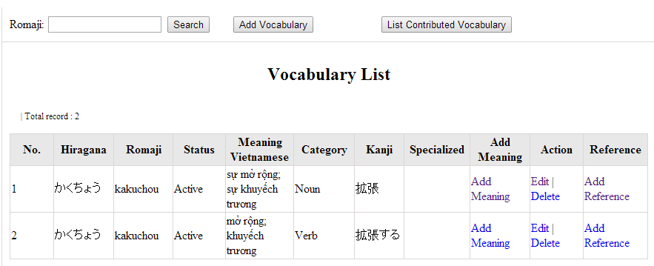

Figure 7.1: Search vocabulary

|  |  |  |  |  |
| --- | --- | --- | --- | --- |
| **UC0024 – Specification** | | | | |
| **Use-case No.** | <UC0024> | **Use-case Version** | | <1.0> |
| **Use-case Name** | Search vocabulary | | | |
| **Author** | TuanNN | | | |
| **Date** | 09/06/2014 | **Priority** | <High > | |
| **Actor:**  Admin  **Summary:**  When Administrator want to search a vocabulary on database  **Goal:**  Administrator can search vocabulary in database successfully if it is existed  **Triggers**  Admin login the website and click on “Vocabulary management” tab, input vocabulary in the right text box then click “Search” button  **Preconditions:**   * Website is available * Admin must be login * Input data must be correctly   **Post Conditions:**  Display detail information of vocabulary  **Main Success Scenario:**   |  |  |  | | --- | --- | --- | | **Step** | **User** | **System** | | 1 | Enter website link on web browser | Display Homepage screen | | 2 | Enter necessary and mandatory information and click "Login” | Redirect to previous page and logged admin into system. | | 4 | Click on “vocabulary management” tab | Displays criteria search screen | | 5 | Fill information of the vocabulary that they want to find into these fields then click “Search” button | Displays search result as a table with these elements:   * No * Hiragana * Romaji * Status * Meaning * Category * Kanji * Specialized * Add meaning * Edit * Delete * Add reference |     **Alternative Scenario:**   |  |  |  | | --- | --- | --- | | **At Step** | **User** | **System** | | 5 | Fill information of the vocabulary that they want to find into these fields then click on another link | Switch to selected page |   **Exceptions:**   |  |  |  | | --- | --- | --- | | **At Step** | **User** | **System** | | 5 | Fill information of the vocabulary that they want to find (that do not exited in database) into these fields then click “Search” button | Return Error message to inform that vocabulary structure cannot be found | | | | | |

##### UC025 <Vocabulary Management>: Add vocabulary

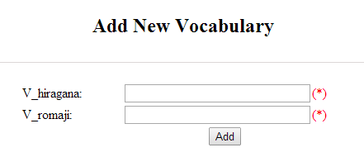

Figure 7.2: Add new vocabulary

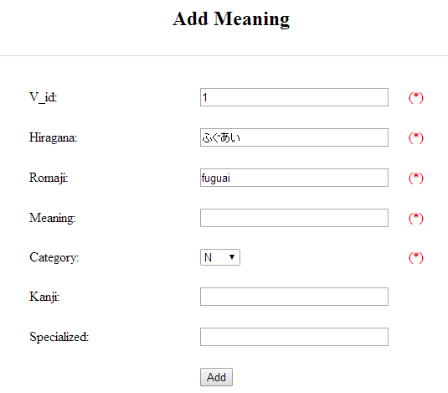

Figure 7.2.1: Add vocabulary meaning

Table 7.2: Add new vocabulary & meaning’s screen description:

|  |  |  |  |  |  |  |
| --- | --- | --- | --- | --- | --- | --- |
| No | Field name | Type | Require | Mandatory | Max-Length | Description |
| 1 | Hiragana | Text | Text | Y | 200 | Admin input vocabulary by hiragana with length less than 200 characters |
| 2 | Romaji | Text | Text | Y | 200 | Admin input vocabulary by romaji with length less than 200 characters |
| 3 | Meaning | Text | Text | Y | 500 | Admin input mean of vocabulary with length less than 500 characters |
| 4 | Category | Drop-down list | Click | Y |  | Admin choose category of vocabulary |
| 5 | Kanji | Text | Text | Y | 10 | Admin input vocabulary by kanji with length less than 10 characters |
| 6 | Specialized | Text | Text | Y | 200 | Admin input specialized of vocabulary with leng less than 200 characters |
| 7 | Add | Button | Click | Y |  | Admin add new vocabulary |

|  |  |  |  |  |
| --- | --- | --- | --- | --- |
| **UC0025 - Specification** | | | | |
| **Use-case No.** | <UC0025> | **Use-case Version** | | <1.0> |
| **Use-case Name** | Add vocabulary | | | |
| **Author** | Tuan NN | | | |
| **Date** | 09/06/2014 | **Priority** | <High > | |
| **Actor:**  Admin  **Summary:**  When Administrator want to add a vocabulary into database. They have to insert all necessary data of vocabulary into “Add new vocabulary” screen  **Goal:**  Administrator can add new vocabulary information in database successfully  **Triggers**  User must click on “Vocabulary management/ Add new” tab and input all necessary information of vocabulary into the right fields then click on “Add new” button  **Preconditions:**   * Website is available * User have logged into system as an admin. * All mandatory fields have been filled * All input data must be valid and have not existed in system   **Post Conditions:**  New vocabulary has been saved into system database successfully  **Main Success Scenario:**   |  |  |  | | --- | --- | --- | | **Step** | **User** | **System** | | 1 | Enter website link on web browser | Display Homepage screen | | 2 | Enter necessary and mandatory information and click "Login” | Redirect to previous page and logged admin into system. | | 3 | Click on “Vocabulary management/Add new” tab | Display “Add New Vocabulary” screen that contains these elements:   * Hiragana * Romaji | | 4 | Fill information into all necessary or mandatory fields and click “Add” button | The system validates the input data and then save new vocabulary data into database | | 5 | Click on “Vocabulary management/Add meaning” tab | Display “Add meaning” screen that contains these elements:   * Hiragana * Romaji * Meaning * Category * Kanji * Specialized | | 6 | Fill information into all necessary or mandatory fields and click “Add” button | The system validates the input data and then save new vocabulary data into database | | 7 | Click on “Vocabulary management/Add reference” tab | Display “Add meaning” screen that contains these elements:   * Vocabulary * Meaning * Sentence | | 8 | Choose sentence and click “Add” button | The system validates the input data and then save new vocabulary data into database |     **Alternative Scenario:**   |  |  |  | | --- | --- | --- | | **At Step** | **User** | **System** | | 4 | Click on another link | Do not save new vocabulary data into database then redirect to selected page | | 6 | Click on another link | Do not save meaning data into database then redirect to selected page | | 8 | Click on another link | Do not save reference into database then redirect to selected page |   **Exceptions:**   |  |  |  | | --- | --- | --- | | **At Step** | **User** | **System** | | 4 | Do not fill full information into fields then click “Add” button | Return Error message beside empty field and ask if user want to add with empty field. | | 6 | Do not fill full information into fields then click “Add” button | Return Error message beside empty field and ask if user want to add with empty field. | | 8 | Do not fill full information into fields then click “Add” button | Return Error message beside empty field and ask if user want to add with empty field. | | | | | |

##### UC026 <Vocabulary Management>: Edit vocabulary

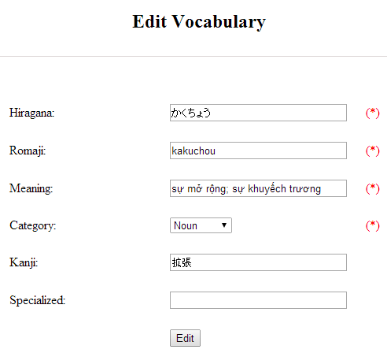

Figure 7.3: Edit vocabulary

Table 7.3: Edit vocabulary’s screen description:

|  |  |  |  |  |  |  |
| --- | --- | --- | --- | --- | --- | --- |
| No | Field name | Type | Require | Mandatory | Max-Length | Description |
| 1 | Hiragana | Text | Text | Y | 200 | Admin input vocabulary by hiragana with length less than 200 characters |
| 2 | Romaji | Text | Text | Y | 200 | Admin input vocabulary by romaji with length less than 200 characters |
| 3 | Meaning | Text | Text | Y | 500 | Admin input mean of vocabulary with length less than 500 characters |
| 4 | Category | Drop-down list | Click | Y |  | Admin choose category of vocabulary |
| 5 | Kanji | Text | Text | Y | 10 | Admin input vocabulary by kanji with length less than 10 characters |
| 6 | Specialized | Text | Text | Y | 200 | Admin input specialized of vocabulary with leng less than 200 characters |
| 7 | Edit | Button | Click | Y |  | Admin edit vocabulary |

|  |  |  |  |  |
| --- | --- | --- | --- | --- |
| **UC0026 - Specification** | | | | |
| **Use-case No.** | <UC0026> | **Use-case Version** | | <1.0> |
| **Use-case Name** | Edit vocabulary | | | |
| **Author** | TuanNN | | | |
| **Date** | 09/06/2014 | **Priority** | <High > | |
| **Actor:**  Admin  **Summary:**  When Administrator want to edit a vocabulary on database which has some new meanings or errors  **Goal:**  Administrator can edit vocabulary information in database successfully  **Triggers**  User must click on “Vocabulary management” then search for the vocabulary. User click on “Edit” link on corresponding vocabulary. They edit necessary information in the right fields then click on “Edit” button.  **Preconditions:**   * Website is available * User have logged into system as an admin. * All mandatory fields have been filled * All input data must be valid and have not existed in system   **Post Conditions:**  Changed information of vocabulary has been saved into system database successfully  **Main Success Scenario:**   |  |  |  | | --- | --- | --- | | **Step** | **User** | **System** | | 1 | Enter website link on web browser | Display Homepage screen | | 2 | Enter necessary and mandatory information and click "Login” | Redirect to previous page and logged admin into system. | | 3 | Click on “Vocabulary management ” then search for the vocabulary that they want to edit | Displays search result as a table | | 4 | Click on “Edit” link | Display “Edit Vocabulary” screen that contains the information of chosen vocabulary with these elements:   * Hiragana * Romaji * Meaning * Category * Kanji * Specialized | | 5 | Edit vocabulary information and click “Edit” button | The system validates the input data and then save data into database |     **Alternative Scenario:**   |  |  |  | | --- | --- | --- | | **At Step** | **User** | **System** | | 4 | Edit vocabulary information then click to another link | Do not save edited data then redirect to selected page |   **Exceptions:**   |  |  |  | | --- | --- | --- | | **At Step** | **User** | **System** | | 4 | Edit vocabulary information to be similar to another existed grammar and click “Edit” button | The system validates the input data and return Error message and do not save edited data into database |   **Reference:**  UC0024 - Search Vocabulary | | | | |

##### UC027 <Vocabulary Management>: Delete vocabulary

|  |  |  |  |  |
| --- | --- | --- | --- | --- |
| **UC0027 - Specification** | | | | |
| **Use-case No.** | <UC0027> | **Use-case Version** | | <1.0> |
| **Use-case Name** | Delete vocabulary | | | |
| **Author** | TuanNN | | | |
| **Date** | 09/06/2014 | **Priority** | <High > | |
| **Actor:**  Admin  **Summary:**  When Administrator want to delete a vocabulary on database  **Goal:**  Administrator can delete selected vocabulary in database successfully  **Triggers**  User must click on “Vocabulary management” then search for the vocabulary. User click on “Delete” link on corresponding vocabulary.  **Preconditions:**   * Website is available * User have logged into system as an admin. * All mandatory fields have been filled * All input data must be valid and have existed in system   **Post Conditions:**  Vocabulary has been deleted from system database successfully  **Main Success Scenario:**   |  |  |  | | --- | --- | --- | | **Step** | **User** | **System** | | 1 | Enter website link on web browser | Display Homepage screen | | 2 | Enter necessary and mandatory information and click "Login” | Redirect to previous page and logged admin into system. | | 3 | Click on “Vocabulary management ” then search for the vocabulary that they want to delete | Displays search result as a table | | 4 | Click on “Delete” link beside that vocabulary row | Remove that vocabulary from list |   **Exceptions:**   |  |  |  | | --- | --- | --- | | **At Step** | **User** | **System** | |  |  |  |   **Reference:**  UC0024 - Search vocabulary | | | | |
|  | | | | |

### 文法•マネージメント

#### 使用事例図表

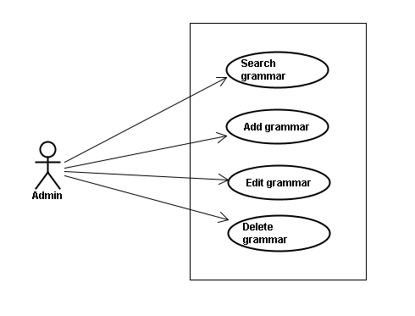

#### スクリーン•デスクリプション

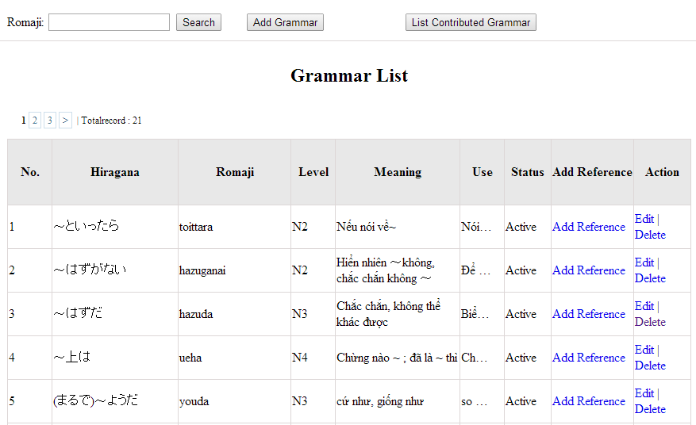

Figrure 8: Grammar management

Table 8.1: Grammar management’s screen description:

|  |  |  |  |  |  |  |
| --- | --- | --- | --- | --- | --- | --- |
| No | Field name | Type | Require | Mandatory | Max-Length | Description |
| 1 | Romaji | Text | Text | Y | 100 | Admin input romaji with length less than 100 character |
| 2 | Add-new | Button | Click | N |  | Admin add new grammar into database |
| 3 | Edit | Button | Click | N |  | Admin click edit grammar |
| 4 | Delete | Button | Click | N |  | Admin click delete grammar |
| 5 | Add-reference | Button | Click | N |  | Admin add reference of grammar |
| 6 | List-contribute | Button | Click | N |  | Admin click to view list contribute |

#### 使用書例仕様

##### UC0028: <Admin> Search grammar

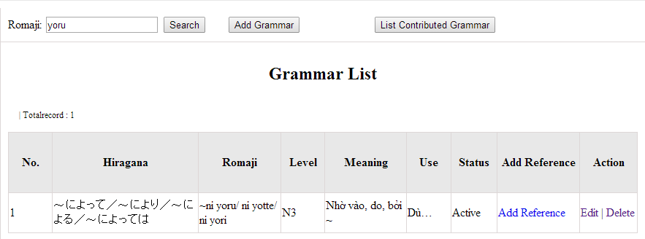

Figure 8.1: Search grammar

|  |  |  |  |  |
| --- | --- | --- | --- | --- |
| **UC0028 - Specification** | | | | |
| **Use-case No.** | <UC0028> | **Use-case Version** | | <1.0> |
| **Use-case Name** | Search grammar | | | |
| **Author** | Minh PT | | | |
| **Date** | 09/06/2014 | **Priority** | <High > | |
| **Actor:**  Admin  **Summary:**  When Administrator wants to search a grammatical structure in database, Admin can input a grammatical structure by “romaji” letter then click button “Search”. If that grammatical structure is existed, system will return meaning.  **Triggers**  Click on “Grammar management” tab, input grammatical structure in the right text box then click “Search” button  **Preconditions:**   * Website is available * User has to login as Administrator * User has to input data in search area   **Post Conditions:**  Display detail information of grammatical structure  **Main Success Scenario:**   |  |  |  | | --- | --- | --- | | **Step** | **User** | **System** | | 1 | Have logged into system as an admin |  | | 2 | Click on “Grammar management” tab | Displays criteria search screen | | 3 | Fill information of the grammatical structure that they want to find into these fields then click “Search” button | Displays search result as a table with these elements:   * No * Hiragana * Romaji * Level * Meaning * Use * Status * Add reference * Edit * Delete |     **Alternative Scenario:**   |  |  |  | | --- | --- | --- | | **At Step** | **User** | **System** | | 3 | Fill information of the grammatical structure that they want to find into these fields then click on another link | Switch to selected page |   **Exceptions:**   |  |  |  | | --- | --- | --- | | **At Step** | **User** | **System** | | 3 | Fill information of the grammatical structure that they want to find (that do not exited in database) into these fields then click “Search” button | Return Error message to inform that grammatical structure cannot be found | | | | | |

##### UC0029: <Admin> Add grammar

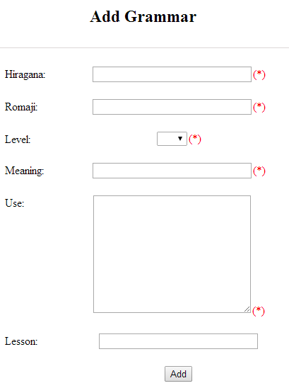

Figure 8.2: Add grammar

Table 8.2: Add grammar’s screen description:

|  |  |  |  |  |  |  |
| --- | --- | --- | --- | --- | --- | --- |
| No | Field name | Type | Require | Mandatory | Max-Length | Description |
| 1 | Hiragana | Text | Text | Y | 200 | Admin input grammar by hiragana with length less than 200 characters |
| 2 | Romaji | Text | Text | Y | 200 | Admin input grammar by romaji with length less than 200 characters |
| 3 | Meaning | Text | Text | Y | 200 | Admin input mean of grammar with length less than 200 characters |
| 4 | Use | Text | Text | Y | 1000 | Admin input use of grammar with length less than 1000 characters |
| 5 | Level | Drop-down list | Choose | Y |  | Admin choose level of grammar |
| 6 | Lesson | Text | Text | Y | 20 | Admin input lesson |
| 7 | Add | Button | Click | Y |  | Admin add new grammar |

|  |  |  |  |  |
| --- | --- | --- | --- | --- |
| **UC0029 - Specification** | | | | |
| **Use-case No.** | <UC0029> | **Use-case Version** | | <1.0> |
| **Use-case Name** | Add grammar | | | |
| **Author** | Minh PT | | | |
| **Date** | 09/06/2014 | **Priority** | <High > | |
| **Actor:**  Admin  **Summary:**  When Administrator wants to add a grammar into database. They have to insert all necessary data of grammar into “Add Grammar” screen then click “Add” button  **Triggers**  User must click on “Grammar management/ Add New” and input all necessary information of grammar into the right fields then click on “Add” button  **Preconditions:**   * Website is available * User has to login as Administrator * All mandatory fields have been filled * All input data must be valid and have not existed in system   **Post Conditions:**  New grammatical structure has been saved into system database successfully  **Main Success Scenario:**   |  |  |  | | --- | --- | --- | | **Step** | **User** | **System** | | 1 | Have logged into system as an admin |  | | 2 | Click on “Grammar management/Add New” | Display “Add Grammar” screen that contains these elements:   * Hiragana * Romaji * Level * Meaning * Use * Lesson | | 3 | Fill grammar information into all necessary or mandatory fields and click “Add” button | The system validates the input data and then save new grammar data into database | | 4 | Click on “Grammar management/Add Reference” | Display “Add Grammar” screen that contains these elements:   * Grammar * Meaning * Reference | | 5 | Fill grammar information into all necessary or mandatory fields and click “Add” button | The system validates the input data and then save new grammar data into database |     **Alternative Scenario:**   |  |  |  | | --- | --- | --- | | **At Step** | **User** | **System** | | 3 | Click on another link | Do not save new grammar data into database then redirect to selected page | | 5 | Click on another link | Do not save new reference data into database then redirect to selected page |   **Exceptions:**   |  |  |  | | --- | --- | --- | | **At Step** | **User** | **System** | | 3 | Do not fill full information into fields then click “Add” button | Return Error message and request user input data into all fields | | 5 | Do not fill full information into fields then click “Add” button | Return Error message and request user input data into all fields | | | | | |

##### UC0030: <Admin> Edit grammar

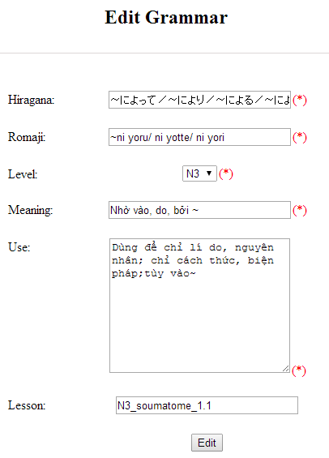

Figure 8.3: Edit grammar

Table 8.3: Edit vocabulary’s screen description:

|  |  |  |  |  |  |  |
| --- | --- | --- | --- | --- | --- | --- |
| No | Field name | Type | Require | Mandatory | Max-Length | Description |
| 1 | Hiragana | Text | Text | Y | 200 | Admin input grammar by hiragana with length less than 200 characters |
| 2 | Romaji | Text | Text | Y | 200 | Admin input grammar by romaji with length less than 200 characters |
| 3 | Meaning | Text | Text | Y | 200 | Admin input mean of grammar with length less than 200 characters |
| 4 | Use | Text | Text | Y | 1000 | Admin input use of grammar with length less than 1000 characters |
| 5 | Level | Drop-down list | Choose | Y |  | Admin choose level of grammar |
| 6 | Lesson | Text | Text | Y | 20 | Admin input lesson |
| 7 | Add | Button | Click | Y |  | Admin add new grammar |

|  |  |  |  |  |
| --- | --- | --- | --- | --- |
| **UC0030 - Specification** | | | | |
| **Use-case No.** | <UC0030> | **Use-case Version** | | <1.0> |
| **Use-case Name** | Edit grammar | | | |
| **Author** | Minh PT | | | |
| **Date** | 09/06/2014 | **Priority** | <High > | |
| **Actor:**  Admin  **Summary:**  When Administrator want to edit a grammatical structure in database which has some new meanings or errors. Admin will search that grammar then click “Edit” link. When edit finished, new meaning of that grammar will be updated.  **Triggers**  User must click on “Grammar management” then search for the grammatical structure. User click on “Edit” link corresponding with grammar which want to edit. User edit necessary information of grammar in the right fields then click on “Edit” button.  **Preconditions:**   * Website is available * User has to login as Administrator * All mandatory fields have been filled * All input data must be valid and have not existed in system   **Post Conditions:**  Changed information of grammar has been saved into system database successfully  **Main Success Scenario:**   |  |  |  | | --- | --- | --- | | **Step** | **User** | **System** | | 1 | Have logged into system as an admin |  | | 2 | Click on “Management grammar ” then search for the grammatical structure that they want to edit | Displays search result as a table | | 3 | Click on “Edit” link corresponding with grammar | Display “Edit Grammar” screen that contains the information of chosen grammar with these elements:   * Hiragana * Romaji * Level * Meaning * Use * Lesson | | 4 | Edit grammar information and click “Edit” button | The system validates the input data and then save data into database |     **Alternative Scenario:**   |  |  |  | | --- | --- | --- | | **At Step** | **User** | **System** | | 4 | Edit grammar information then click to another link | Do not save edited data then redirect to selected page |   **Exceptions:**   |  |  |  | | --- | --- | --- | | **At Step** | **User** | **System** | | 4 | Edit grammar information to be similar to another existed grammar and click “Edit” button | The system validates the input data and return Error message and do not save edited data into database |   **Reference:**  UC0028 - <Admin> Search Grammar | | | | |

##### UC0031: <Admin> Delete grammar

|  |  |  |  |  |
| --- | --- | --- | --- | --- |
| **UC0031 - Specification** | | | | |
| **Use-case No.** | <UC0031> | **Use-case Version** | | <1.0> |
| **Use-case Name** | Delete grammar | | | |
| **Author** | Minh PT | | | |
| **Date** | 09/06/2014 | **Priority** | <High > | |
| **Actor:**  Admin  **Summary:**  When Administrator want to delete a grammar in database. Admin will search that grammar then click “Delete” link. When deleted finished, that grammar no longer exist in database.  **Triggers**  User must click on “Grammar management” then search for the grammatical structure. User click on “Delete” link corresponding with grammar which want to delete.  **Preconditions:**   * Website is available * User has to login as Administrator   **Post Conditions:**  Grammar has been deleted from system database successfully  **Main Success Scenario:**   |  |  |  | | --- | --- | --- | | **Step** | **User** | **System** | | 1 | Have logged into system as an admin |  | | 2 | Click on “Grammar management ” then search for the grammar that they want to delete | Displays search result as a table | | 3 | Click on “Delete” link corresponding with grammar | Remove that grammar in database |   **Reference:** UC0028 - <Admin> Search grammar | | | | |
|  | | | | |

### リーディング•ドキュメント•マネージメント

#### 使用事例図表

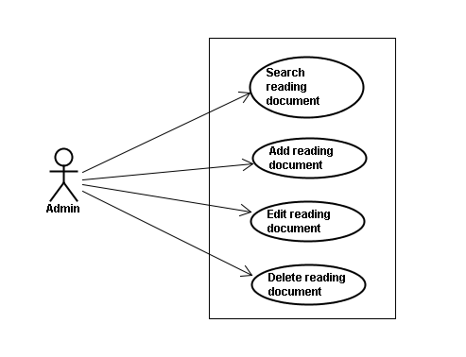

#### スクリーン•デスクリプション

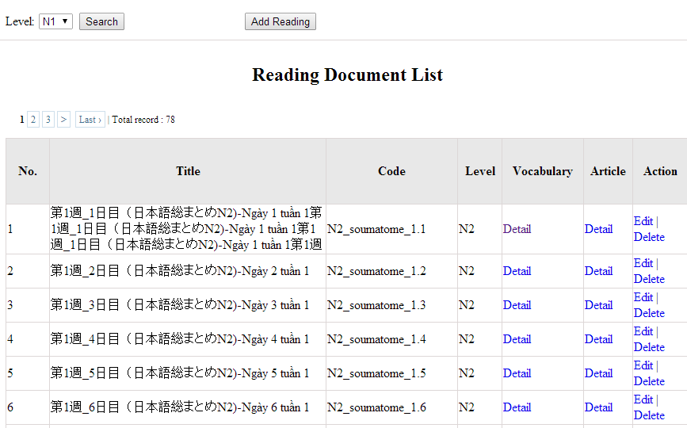

Figure 9: Reading document

Table 9: Reading document’s screen description:

|  |  |  |  |  |  |  |
| --- | --- | --- | --- | --- | --- | --- |
| No | Field name | Type | Require | Mandatory | Max-Length | Description |
| 1 | Level | Drop-down list | Click | Y |  | Admin choose the level |
| 2 | Search | Button | Click | Y |  | Admin click to search |
| 3 | Add-new | Button | Click | N |  | Admin add new into database |
| 4 | Edit | Button | Click | N |  | Admin click edit grammar |
| 5 | Delete | Button | Click | N |  | Admin click delete grammar |
| 6 | Detail-Vocab | Hyperlink | Click | N |  | Details of vocabulary |
| 7 | Detail-Article | Hyperlink | Click | N |  | Details of article |

#### 使用書例仕様

##### UC0032: <Admin> Search reading document

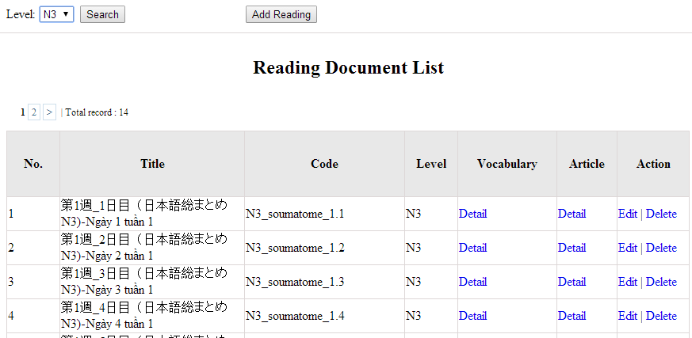

Figure 9.1 : Search reading document

|  |  |  |  |  |
| --- | --- | --- | --- | --- |
| **UC0032 - Specification** | | | | |
| **Use-case No.** | <UC0032> | **Use-case Version** | | <1.0> |
| **Use-case Name** | Search document | | | |
| **Author** | Minh PT | | | |
| **Date** | 09/06/2014 | **Priority** | <High > | |
| **Actor:**  Admin  **Summary:**  When Administrator want to search reading document in database and Administrator can search reading document in database successfully if it is existed  **Triggers**  Click on “Reading management” tab, input name of reading document in the right text box then click “Search” button  **Preconditions:**  Input data must be correctly and User has to login as Administrator user  **Post Conditions:**  Display detail information of reading document  **Main Success Scenario:**   |  |  |  | | --- | --- | --- | | **Step** | **User** | **System** | | 1 | Have logged into system as an admin |  | | 2 | Click on “Reading management” tab | Displays criteria search screen | | 3 | Fill information of the reading document that they want to find into these fields then click “Search” button | Displays search result as a table with these elements:   * No * Title * Code * Level * Vocabulary * Article * Edit * Delete |     **Alternative Scenario:**   |  |  |  | | --- | --- | --- | | **At Step** | **User** | **System** | | 3 | Fill information of the reading document that they want to find into these fields then click on another link | Switch to selected page |   **Exceptions:**   |  |  |  | | --- | --- | --- | | **At Step** | **User** | **System** | | 3 | Fill information of the reading document that they want to find (that do not exited in database) into these fields then click “Search” button | Return Error message to inform that reading document cannot be found | | | | | |

##### UC0033: <Admin> Add reading document

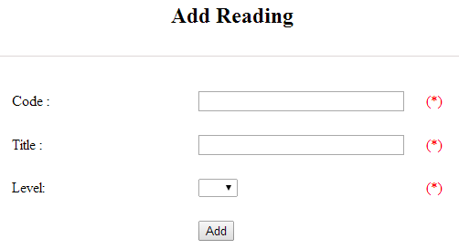

Figure 9.2 : Add reading document

Table 9.2 : Add reading document’s screen description:

|  |  |  |  |  |  |  |
| --- | --- | --- | --- | --- | --- | --- |
| No | Field name | Type | Require | Mandatory | Max-Length | Description |
| 1 | Code | Text | Text | Y | 50 | Admin input code with length less than 50 character |
| 2 | Title | Text | Text | Y | 100 | Admin input title with length less than 100 characters |
| 3 | Level | Drop-down list | Click | Y |  | Admin choose the level |
| 4 | Add | Button | Click | Y |  | Admin click to add reading |

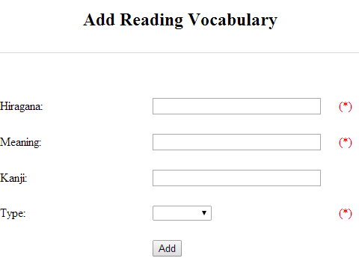

Figure 9.2.1 : Add reading vocabulary

Table 9.2.1 : Add reading vocabulary’s screen description:

|  |  |  |  |  |  |  |
| --- | --- | --- | --- | --- | --- | --- |
| No | Field name | Type | Require | Mandatory | Max-Length | Description |
| 1 | Hiragana | Text | Text | Y | 100 | Admin input hiragana with length less than 100 character |
| 2 | Meaning | Text | Text | Y | 100 | Admin input meaning with length less than 100 characters |
| 3 | Kanji | Text | Text | N | 10 | Admin input kanji with length less than 10 characters |
| 4 | Type | Drop-down list | Click | Y |  | Admin choose the type |
| 5 | Add | Button | Click | Y |  | Admin click to add reading vocabulary |

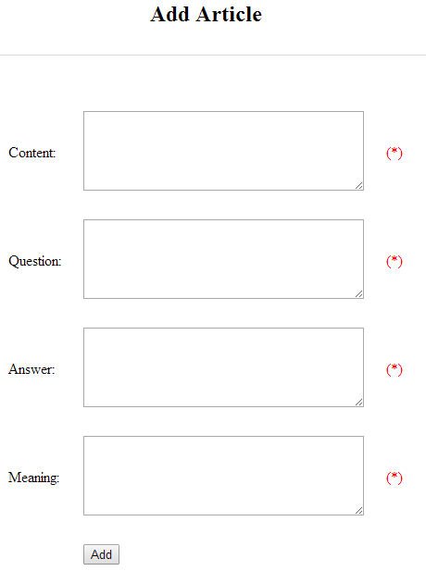

Figure 9.2.2 : Add article

Table 9.2.2 : Add article’s screen description:

|  |  |  |  |  |  |  |
| --- | --- | --- | --- | --- | --- | --- |
| No | Field name | Type | Require | Mandatory | Max-Length | Description |
| 1 | Content | Text | Text | Y | 5000 | Admin input content with length less than 5000 character |
| 2 | Question | Text | Text | Y | 5000 | Admin input question with length less than 5000 characters |
| 3 | Answer | Text | Text | Y | 5000 | Admin input answer with length less than 5000 characters |
| 4 | Meaning | Text | Text | Y | 5000 | Admin input meaning with length less than 5000 characters |
| 5 | Add | Button | Click | Y |  | Admin click to add article |

|  |  |  |  |  |
| --- | --- | --- | --- | --- |
| **UC0030 - Specification** | | | | |
| **Use-case No.** | <UC0030> | **Use-case Version** | | <1.0> |
| **Use-case Name** | Add document | | | |
| **Author** | Minh PT | | | |
| **Date** | 09/06/2014 | **Priority** | <High > | |
| **Actor:**  Admin  **Summary:**  When Administrator want to add new reading document into database. They have to insert all necessary data of reading document into “Add new reading” screen  **Triggers**  User must click on “Reading management/ Add new” tab and input all necessary information of grammar into the right fields then click on “Add new” button  **Preconditions:**   * User have logged into system as an admin. * All mandatory fields have been filled * All input data must be valid and have not existed in system   **Post Conditions:**  New reading document has been saved into system database successfully  **Main Success Scenario:**   |  |  |  | | --- | --- | --- | | **Step** | **User** | **System** | | 1 | Have logged into system as an admin |  | | 2 | Click on “Reading management/Add new” tab | Display “Add New Reading” screen that contains these elements:   * Code * Title * Level | | 3 | Fill reading document information into all necessary or mandatory fields and click “Add ” button | The system validates the input data and then save new reading document data into database | | 4 | Click on “Reading management/VocabularyDetails” | Display “Vocabulary_Details” screen that contains these elements:   * Hiragana * Meaning * Kanji * Type | | 5 | Fill reading document information into all necessary or mandatory fields and click “Add ” button | The system validates the input data and then save new reading document data into database | | 6 | Click on “Reading management/ArticleDetails” | Display “Article_Details” screen that contains these elements:   * Cotent * Question * Answer * Meaning | | 7 | Fill reading document information into all necessary or mandatory fields and click “Add ” button | The system validates the input data and then save new reading document data into database |     **Alternative Scenario:**   |  |  |  | | --- | --- | --- | | **At Step** | **User** | **System** | | 3 | Click on another link | Do not save new reading document data into database then redirect to selected page | | 5 | Click on another link | Do not save vocabulary details data into database then redirect to selected page | | 7 | Click on another link | Do not save article details data into database then redirect to selected page |   **Exceptions:**   |  |  |  | | --- | --- | --- | | **At Step** | **User** | **System** | | 3 | Do not fill full information into fields then click “Add new” button | Return Error message beside empty field and ask if user want to add with empty field. | | 5 | Do not fill full information into fields then click “Add new” button | Return Error message beside empty field and ask if user want to add with empty field. | | 7 | Do not fill full information into fields then click “Add new” button | Return Error message beside empty field and ask if user want to add with empty field. | | | | | |

##### UC0034: <Admin> Edit reading document

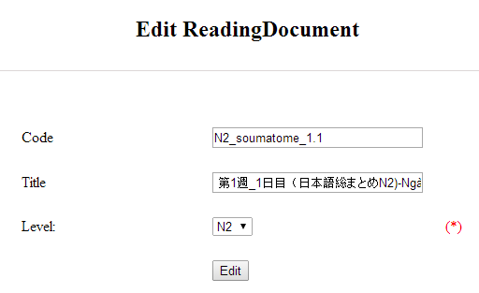

Figure 9.3 : Edit reading document

Table 9.3 : Edit reading document’s screen description:

|  |  |  |  |  |  |  |
| --- | --- | --- | --- | --- | --- | --- |
| No | Field name | Type | Require | Mandatory | Max-Length | Description |
| 1 | Code | Text | Text | Y | 50 | Admin input code with length less than 50 character |
| 2 | Title | Text | Text | Y | 100 | Admin input title with length less than 100 characters |
| 3 | Level | Drop-down list | Click | Y |  | Admin choose the level |
| 4 | Edit | Button | Click | Y |  | Admin click to edit reading |

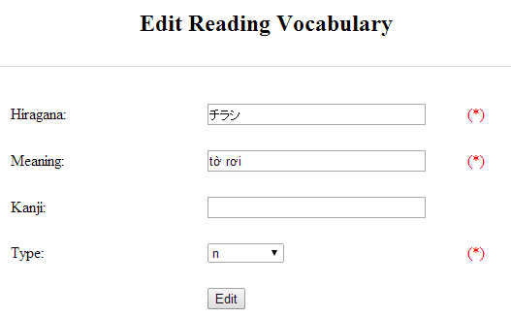

Figure 9.3.1 : Add reading vocabulary

Table 9.3.1 : Add reading vocabulary’s screen description:

|  |  |  |  |  |  |  |
| --- | --- | --- | --- | --- | --- | --- |
| No | Field name | Type | Require | Mandatory | Max-Length | Description |
| 1 | Hiragana | Text | Text | Y | 100 | Admin input hiragana with length less than 100 character |
| 2 | Meaning | Text | Text | Y | 100 | Admin input meaning with length less than 100 characters |
| 3 | Kanji | Text | Text | N | 10 | Admin input kanji with length less than 10 characters |
| 4 | Type | Drop-down list | Click | Y |  | Admin choose the type |
| 5 | Edit | Button | Click | Y |  | Admin click to edit reading vocabulary |

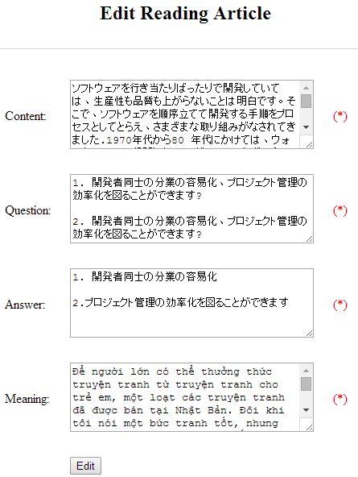

Figure 9.3.2 : Add article

Table 9.3.2 : Add article’s screen description:

|  |  |  |  |  |  |  |
| --- | --- | --- | --- | --- | --- | --- |
| No | Field name | Type | Require | Mandatory | Max-Length | Description |
| 1 | Content | Text | Text | Y | 5000 | Admin input content with length less than 5000 character |
| 2 | Question | Text | Text | Y | 5000 | Admin input question with length less than 5000 characters |
| 3 | Answer | Text | Text | Y | 5000 | Admin input answer with length less than 5000 characters |
| 4 | Meaning | Text | Text | Y | 5000 | Admin input meaning with length less than 5000 characters |
| 5 | Edit | Button | Click | Y |  | Admin click to edit article |

|  |  |  |  |  |
| --- | --- | --- | --- | --- |
| **UC0034 - Specification** | | | | |
| **Use-case No.** | <UC0034> | **Use-case Version** | | <1.0> |
| **Use-case Name** | Edit reading document | | | |
| **Author** | Minh PT | | | |
| **Date** | 09/06/2014 | **Priority** | <High > | |
| **Actor:**  Admin  **Summary:**  When Administrator want to edit reading document on database which has some new meanings or errors  **Triggers**  User must click on “Reading management” then search for the reading document. User click on “Edit” link on corresponding reading document. They edit necessary information of reading document in the right fields then click on “Edit” button.  **Preconditions:**   * User have logged into system as an admin. * All mandatory fields have been filled * All input data must be valid and have not existed in system   **Post Conditions:**  Changed information of reading document has been saved into system database successfully  **Main Success Scenario:**   |  |  |  | | --- | --- | --- | | **Step** | **User** | **System** | | 1 | Have logged into system as an admin |  | | 2 | Click on “Reading management ” then search for the reading document that they want to edit | Displays search result as a table | | 3 | Click on “Edit” link | Display “Edit reading” screen that contains the information of chosen reading with these elements:   * Code * Title * Level | | 4 | Edit reading document information and click “Edit” button | The system validates the input data and then save data into database | | 5 | Click on “VocabularyEdit” link | Display “Edit vocabulary” screen that contains the information of chosen reading with these elements:   * Hiragana * Meaning * Kanji * Type | | 6 | Edit reading document information and click “Edit” button | The system validates the input data and then save data into database | | 7 | Click on “ArticleEdit” link | Display “Edit article” screen that contains the information of chosen reading with these elements:   * Content * Question * Answer * Meaning | | 8 | Edit reading document information and click “Edit” button | The system validates the input data and then save data into database |     **Alternative Scenario:**   |  |  |  | | --- | --- | --- | | **At Step** | **User** | **System** | | 4 | Edit reading information then click to another link | Do not save edited data then redirect to selected page | | 6 | Edit reading information then click to another link | Do not save edited data then redirect to selected page | | 8 | Edit reading information then click to another link | Do not save edited data then redirect to selected page |   **Exceptions:**   |  |  |  | | --- | --- | --- | | **At Step** | **User** | **System** | | 4 | Edit reading information to be similar to another existed reading and click “Edit” button | The system validates the input data and return Error message and do not save edited data into database | | 6 | Edit reading information to be similar to another existed reading and click “Edit” button | The system validates the input data and return Error message and do not save edited data into database | | 8 | Edit reading information to be similar to another existed reading and click “Edit” button | The system validates the input data and return Error message and do not save edited data into database |   **Reference:**  UC0032- <Admin> Search reading document | | | | |

##### UC0035: <Admin> Delete reading document

|  |  |  |  |  |
| --- | --- | --- | --- | --- |
| **UC0035 - Specification** | | | | |
| **Use-case No.** | <UC0035> | **Use-case Version** | | <1.0> |
| **Use-case Name** | Delete reading document | | | |
| **Author** | Minh PT | | | |
| **Date** | 09/06/2014 | **Priority** | <High > | |
| **Actor:**  Admin  **Summary:**  When Administrator want to delete reading document on database  **Triggers**  User must click on “Reading management” then search for the reading document. User click on “Delete” link on corresponding reading document.  **Preconditions:**   * User have logged into system as an admin. * All mandatory fields have been filled * All input data must be valid and have existed in system   **Post Conditions:**  Reading document has been deleted from system database successfully  **Main Success Scenario:**   |  |  |  | | --- | --- | --- | | **Step** | **User** | **System** | | 1 | Have logged into system as an admin |  | | 2 | Click on “Reading management ” then search for the reading document that they want to delete | Displays search result as a table | | 3 | Click on “Delete” link beside that reading document row | Displays pop up to confirm if they really want to remove that reading document | | 4 | Click “Yes” button on popup | Closes the popup then remove that reading document name from reading list |     **Alternative Scenario:**   |  |  |  | | --- | --- | --- | | **At Step** | **User** | **System** | | 4 | Click close icon of the popup | Only closes the popup, does not remove that reading document |   **Exceptions:**   |  |  |  | | --- | --- | --- | | **At Step** | **User** | **System** | | 4 | Click “Cancel” button on popup | Only closes the popup, does not remove that reading document |   **Reference:**  UC0032 - <Admin> Search reading document | | | | |
|  | | | | |

### 会話•マネージメント

#### 使用事例図表

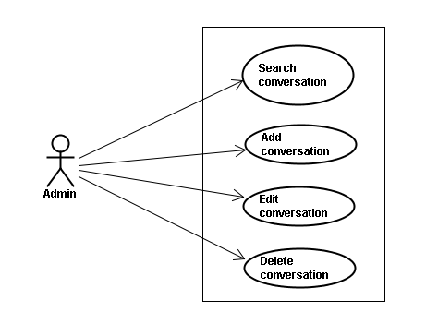

#### スクリーン•デスクリプション

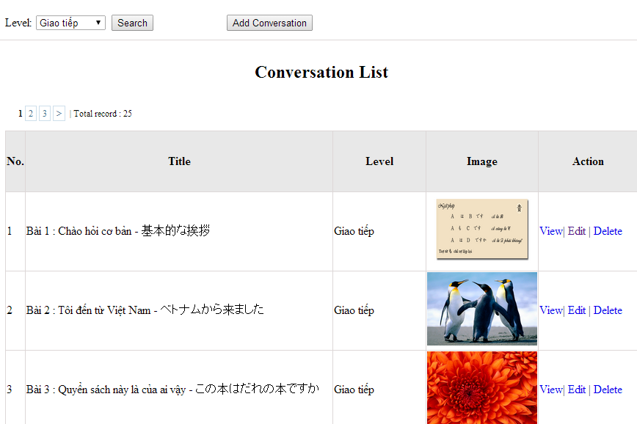

Figure 10: Conversation management

Table 10: Conversation management’s screen description:

|  |  |  |  |  |  |  |
| --- | --- | --- | --- | --- | --- | --- |
| No | Field name | Type | Require | Mandatory | Max-Length | Description |
| 1 | Level | Drop-down list | Click | N |  | Admin choose the level |
| 2 | Search | Button | Click | N |  | Admin click to search conversation |
| 3 | Add-new | Button | Click | N |  | Admin click to add new conversation |
| 4 | View | Hyperlink | Click | N |  | Admin click to view content |
| 5 | Edit | Hyperlink | Click | N |  | Admin click edit conversation |
| 6 | Delete | Hyperlink | Click | N |  | Admin click delete conversation |

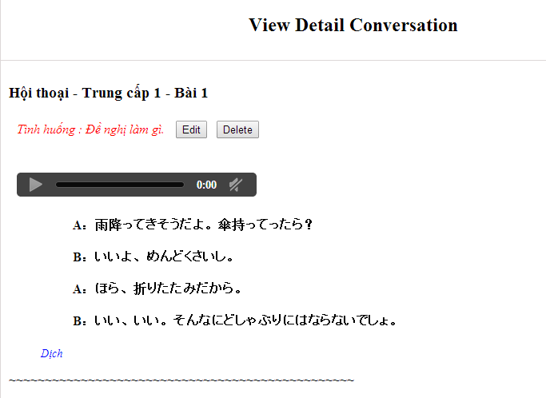

#### 使用書例仕様

##### UC0036: <Admin> Search conversation

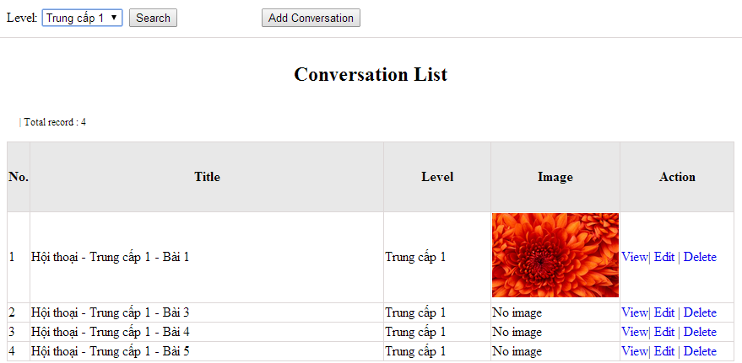

Figure 10.1: Search conversation

|  |  |  |  |  |
| --- | --- | --- | --- | --- |
| **UC0036 - Specification** | | | | |
| **Use-case No.** | <UC0036> | **Use-case Version** | | <1.0> |
| **Use-case Name** | Search conversation | | | |
| **Author** | Minh PT | | | |
| **Date** | 09/06/2014 | **Priority** | <High > | |
| **Actor:**  Admin  **Summary:**  When Administrator wants to search conversation in database. User input name of conversation or level then click “Search” button  **Triggers**  Click on “Conversation management” tab, input name of conversation in the right text box then click “Search” button  **Preconditions:**   * Website is available * User has to login as Administrator * User has to input data in search area   **Post Conditions:**  Display detail information of conversation  **Main Success Scenario:**   |  |  |  | | --- | --- | --- | | **Step** | **User** | **System** | | 1 | Have logged into system as an admin |  | | 2 | Click on “Conversation management” tab | Displays criteria search screen | | 3 | Fill information of the conversation that they want to find into fields: C_id or Level then click “Search” button | Displays search result as a table with these elements:   * No * Title * Level * Image * View * Edit * Delete |     **Alternative Scenario:**   |  |  |  | | --- | --- | --- | | **At Step** | **User** | **System** | | 3 | Fill information of the conversation that they want to find into these fields then click on another link | Switch to selected page |   **Exceptions:**   |  |  |  | | --- | --- | --- | | **At Step** | **User** | **System** | | 3 | Fill information of the conversation that they want to find (that do not exited in database) into these fields then click “Search” button | Return Error message to inform that conversation cannot be found | | | | | |

##### UC0037: <Admin> Add conversation

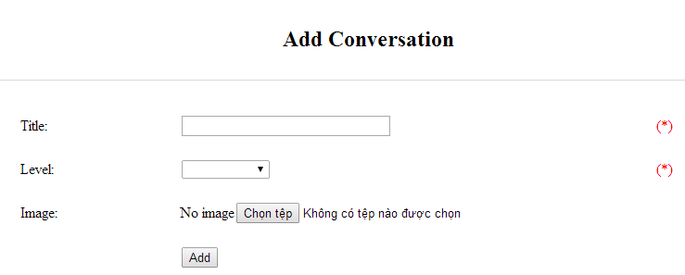

Figure 10.2.1: Add conversation

Table 10.2.1: Add conversation’s screen description:

|  |  |  |  |  |  |  |
| --- | --- | --- | --- | --- | --- | --- |
| No | Field name | Type | Require | Mandatory | Max-Length | Description |
| 1 | Title | Text | Text | Y | 100 | Admin input title of conversation with length less than 100 characters |
| 3 | Level | Drop-down list | Text | Y |  | Admin choose the level |
| 4 | Image | Button | Click | N |  | Admin choose the image |
| 5 | Add | Button | Click | Y |  | Admin add new conversation |

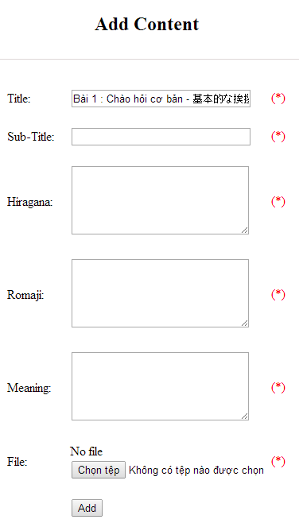

Figure 10.2.2: Add new conversation content

Table 10.2.2: Add conversation content’s screen description:

|  |  |  |  |  |  |  |
| --- | --- | --- | --- | --- | --- | --- |
| No | Field name | Type | Require | Mandatory | Max-Length | Description |
| 1 | Title |  |  |  |  |  |
| 2 | Sub-title | Text | Text | Y | 200 | Admin input subtitle with length less than 200 characters |
| 3 | Hiragana | Text | Text | Y | 5000 | Admin input hiragana with length less than 5000 characters |
| 4 | Romaji | Text | Text | Y | 5000 | Admin input conversation by romaji with length less than 5000 characters |
| 5 | Meaning | Text | Text | Y | 5000 | Admin input conversation’s meaning with length less than 5000 characters |
| 6 | File | Button | Click | Y |  | Admin choose the file |
| 7 | Add | Button | Click | Y |  | Admin add new content |

|  |  |  |  |  |
| --- | --- | --- | --- | --- |
| **UC0037 - Specification** | | | | |
| **Use-case No.** | <UC0037> | **Use-case Version** | | <1.0> |
| **Use-case Name** | Add conversation | | | |
| **Author** | Minh PT | | | |
| **Date** | 09/06/2014 | **Priority** | <High > | |
| **Actor:**  Admin  **Summary:**  When Administrator wants to add new conversation into database. They have to insert all necessary data of conversation into “Add Conversation” screen  **Triggers**  User must click on “Conversation management/ Add New” and input all necessary information of conversation into the right fields then click on “Add” button  **Preconditions:**   * Website is available * User have logged into system as an admin. * All mandatory fields have been filled * All input data must be valid and have not existed in system   **Post Conditions:**  New conversation has been saved into system database successfully  **Main Success Scenario:**   |  |  |  | | --- | --- | --- | | **Step** | **User** | **System** | | 1 | Have logged into system as an admin |  | | 2 | Click on “Conversation management/Add New” | Display “Add Conversation” screen that contains these elements:   * Title * Level * Image | | 3 | Fill conversation information into all necessary or mandatory fields and click “Add” button | The system validates the input data and then save new conversation data into database | | 4 | Click on “Conversation management/View/Add new content” | Display “Add Content” screen that contains these elements:   * Title * Subtitle * Hiragana * Romaji * Meaning * File | | 5 | Fill conversation information into all necessary or mandatory fields and click “Add” button | The system validates the input data and then save new conversation data into database |     **Alternative Scenario:**   |  |  |  | | --- | --- | --- | | **At Step** | **User** | **System** | | 3 | Click on another link | Do not save new conversation data into database then redirect to selected page | | 5 | Click on another link | Do not save new content conversation data into database then redirect to selected page |   **Exceptions:**   |  |  |  | | --- | --- | --- | | **At Step** | **User** | **System** | | 3 | Do not fill full information into fields then click “Add” button | Return Error message and request user input data into all fields | | 5 | Do not fill full information into fields then click “Add” button | Return Error message and request user input data into all fields | | 8 | C_id (that do not exited in database then click “Add” button | Return Error message and request user create name of conversation first | | | | | |

##### UC0038: <Admin> Edit conversation

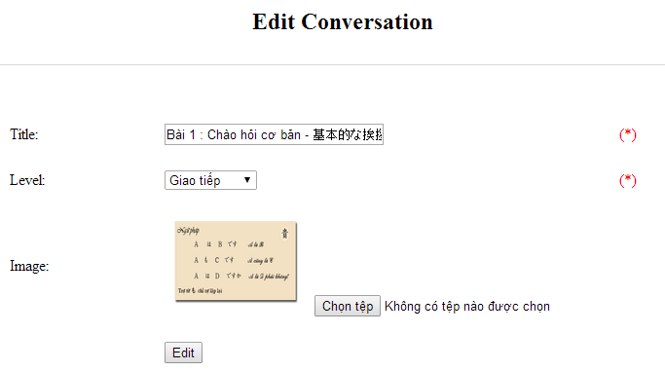

Figure 10.3.1: Edit conversation

Table 10.3.1: Edit conversation’s screen description

|  |  |  |  |  |  |  |
| --- | --- | --- | --- | --- | --- | --- |
| No | Field name | Type | Require | Mandatory | Max-Length | Description |
| 1 | Title | Text | Text | Y | 100 | Admin input title of conversation with length less than 100 characters |
| 3 | Level | Drop-down list | Text | Y |  | Admin choose the level |
| 4 | Image | Button | Click | N |  | Admin choose the image |
| 5 | Edit | Button | Click | Y |  | Admin add edit conversation |

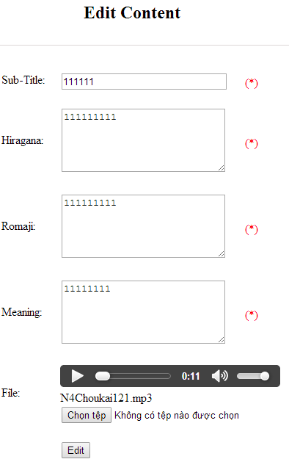

Figure 10.3.2: Edit new conversation content

Table 10.3.2: Edit conversation content’s screen description:

|  |  |  |  |  |  |  |
| --- | --- | --- | --- | --- | --- | --- |
| No | Field name | Type | Require | Mandatory | Max-Length | Description |
| 1 | Sub-title | Text | Text | Y | 200 | Admin input subtitle with length less than 200 characters |
| 2 | Hiragana | Text | Text | Y | 5000 | Admin input hiragana with length less than 5000 characters |
| 3 | Romaji | Text | Text | Y | 5000 | Admin input conversation by romaji with length less than 5000 characters |
| 4 | Meaning | Text | Text | Y | 5000 | Admin input conversation’s meaning with length less than 5000 characters |
| 5 | File | Button | Click | Y |  | Admin choose the file |
| 6 | Edit | Button | Click | Y |  | Admin edit conversation |

|  |  |  |  |  |
| --- | --- | --- | --- | --- |
| **UC0038 - Specification** | | | | |
| **Use-case No.** | <UC0038> | **Use-case Version** | | <1.0> |
| **Use-case Name** | Edit conversation | | | |
| **Author** | Minh PT | | | |
| **Date** | 09/06/2014 | **Priority** | <High > | |
| **Actor:**  Admin  **Summary:**  When Administrator want to edit conversation in database which has some new meanings or errors. When edit finished, new meaning will be updated  **Triggers**  User must click on “Conversation management” then search for the conversation. User click on “Edit” link on corresponding conversation. They edit necessary information of conversation in the right fields then click on “Edit” button.  **Preconditions:**   * Website is available * User have logged into system as an admin. * All mandatory fields have been filled * All input data must be valid and have not existed in system   **Post Conditions:**  Changed information of conversation has been saved into system database successfully  **Main Success Scenario:**   |  |  |  | | --- | --- | --- | | **Step** | **User** | **System** | | 1 | Have logged into system as an admin |  | | 2 | Click on “Conversation management ” then search for the conversation that they want to edit | Displays search result as a table | | 3 | Click on “Edit” link corresponding | Display “Edit conversation” screen that contains the information of chosen conversation with these elements:   * C_id * Level * Title | | 4 | Edit conversation information |  | | 5 | Click “Edit” button | The system validates the input data and then save data into database | | 5 | Click “Reset” button | The system clear all data in text fields | | 6 | Click “Conversation Content Management” then search for the conversation content that they want to edit | Displays search result as a table | | 7 | Click on “Edit” link corresponding | Display “Edit Conversation Content” screen that contains the information of chosen conversation with these elements:   * C_id * Con_hiragana * Con_romaji * Con_meaning | | 8 | Edit conversation content information |  | | 9 | Click “Edit” button | The system validates the input data and then save data into database | | 9 | Click “Reset” button | The system clear all data in text fields |     **Alternative Scenario:**   |  |  |  | | --- | --- | --- | | **At Step** | **User** | **System** | | 4 | Edit conversation then click to another link | Do not save edited data then redirect to selected page | | 8 | Edit conversation content then click to another link | Do not save edited data then redirect to selected page |   **Exceptions:**   |  |  |  | | --- | --- | --- | | **At Step** | **User** | **System** | | 4 | Edit conversation to be similar to another existed conversation |  | | 5 | Click “Edit” button | The system validates the input data and return Error message and do not save edited data into database | | 8 | Edit conversation content to be similar to another existed conversation content |  | | 9 | Click “Edit” button | The system validates the input data and return Error message and do not save edited data into database |   **Reference:**  UC0036- <Admin> Search conversation | | | | |

##### UC0039: <Admin> Delete conversation

|  |  |  |  |  |
| --- | --- | --- | --- | --- |
| **UC0039 - Specification** | | | | |
| **Use-case No.** | <UC0039> | **Use-case Version** | | <1.0> |
| **Use-case Name** | Delete conversation | | | |
| **Author** | Minh PT | | | |
| **Date** | 09/06/2014 | **Priority** | <High > | |
| **Actor:**  Admin  **Summary:**  When Administrator want to delete conversation in database  **Triggers**  User must click on “Conversation management” then search for the conversation. User click on “Delete” link on corresponding conversation.  **Preconditions:**   * Website is available * User have logged into system as an admin.   **Post Conditions:**  Conversation has been deleted from system database successfully  **Main Success Scenario:**   |  |  |  | | --- | --- | --- | | **Step** | **User** | **System** | | 1 | Have logged into system as an admin |  | | 2 | Click on “Conversation management ” then search for the conversation that they want to delete | Displays search result as a table | | 3 | Click on “Delete” link corresponding with conversation | Remove that conversation in database |   **Exceptions:**   |  |  |  | | --- | --- | --- | | **At Step** | **User** | **System** | | 3 | Click on “Delete” link corresponding with conversation (conversation content is existing) | Return Error message and request user remove conversation content first |   **Reference:**  UC0036 - <Admin> Search conversation | | | | |
|  | | | | |

### ビデオ·マネージメント

#### 使用事例図表

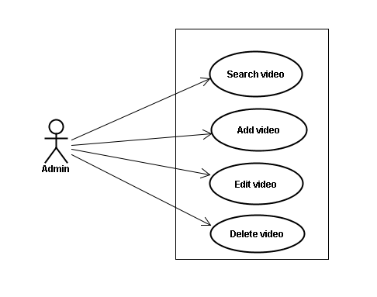

#### スクリーン•デスクリプション

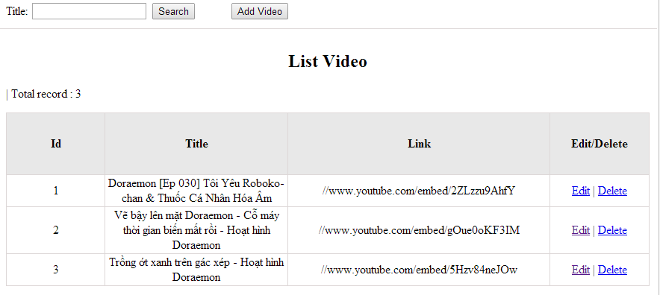

Figrure 11: Video management

Table 11.1: Video management’s screen description:

|  |  |  |  |  |  |  |
| --- | --- | --- | --- | --- | --- | --- |
| No | Field name | Type | Require | Mandatory | Max-Length | Description |
| 1 | Title | Text | Text | Y | 100 | Admin input title with length less than 100 character |
| 2 | Addnew | Button | Click | N |  | Admin add new video into database |
| 3 | Edit | Button | Click | N |  | Admin click edit video |
| 4 | Delete | Button | Click | N |  | Admin click delete video |

#### 使用書例仕様

##### UC040 <Video management>: Search video

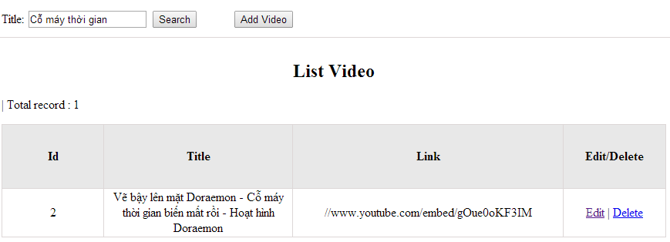

Figure 11.1: Search video

|  |  |  |  |  |
| --- | --- | --- | --- | --- |
| **UC0040 - Specification** | | | | |
| **Use-case No.** | <UC0040> | **Use-case Version** | | <1.0> |
| **Use-case Name** | Search video | | | |
| **Author** | Minh PT | | | |
| **Date** | 09/06/2014 | **Priority** | <High > | |
| **Actor:**  Admin  **Summary:**  When Administrator wants to search video in database. User input name of video then click “Search” button  **Triggers**  Click on “Video management” tab, input name of video in the right text box then click “Search” button  **Preconditions:**   * Website is available * User has to login as Administrator * User has to input data in search area   **Post Conditions:**  Display detail information of video  **Main Success Scenario:**   |  |  |  | | --- | --- | --- | | **Step** | **User** | **System** | | 1 | Have logged into system as an admin |  | | 2 | Click on “Video management” tab | Displays criteria search screen | | 3 | Fill information of the video that they want to find into these fields then click “Search” button | Displays search result as a table with these elements:   * No * Title * Link * Edit * Delete |     **Alternative Scenario:**   |  |  |  | | --- | --- | --- | | **At Step** | **User** | **System** | | 3 | Fill information of the video that they want to find into these fields then click on another link | Switch to selected page |   **Exceptions:**   |  |  |  | | --- | --- | --- | | **At Step** | **User** | **System** | | 3 | Fill information of the video that they want to find (that do not exited in database) into these fields then click “Search” button | Return Error message to inform that video cannot be found | | | | | |

##### UC041 <Video management>: Add video

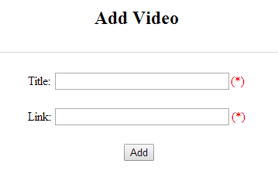

Figure 11.2: Add video

Table 11.2: Add video’s screen description:

|  |  |  |  |  |  |  |
| --- | --- | --- | --- | --- | --- | --- |
| No | Field name | Type | Require | Mandatory | Max-Length | Description |
| 1 | Title | Text | Text | Y | 200 | Admin input title with length less than 200 characters |
| 2 | Link | Text | Text | Y |  | Admin input hyperlink |
| 3 | Add | Button | Click | Y |  | Admin add new video |
| 4 | Reset | Button | Click | N |  | Admin reset information |

|  |  |  |  |  |
| --- | --- | --- | --- | --- |
| **UC0041 - Specification** | | | | |
| **Use-case No.** | <UC0041> | **Use-case Version** | | <1.0> |
| **Use-case Name** | Add video | | | |
| **Author** | Minh PT | | | |
| **Date** | 09/06/2014 | **Priority** | <High > | |
| **Actor:**  Admin  **Summary:**  When Administrator wants to add new video into database. They have to insert all necessary data of video into “Add Video” screen  **Triggers**  User must click on “Video management/ Add New” tab and input all necessary information of video into the right fields then click on “Add” button  **Preconditions:**   * Website is available * User have logged into system as an admin. * All mandatory fields have been filled * All input data must be valid and have not existed in system   **Post Conditions:**  New video has been saved into system database successfully  **Main Success Scenario:**   |  |  |  | | --- | --- | --- | | **Step** | **User** | **System** | | 1 | Have logged into system as an admin |  | | 2 | Click on “Video management/Add New” tab | Display “Add Video” screen that contains these elements:   * Title * Link | | 3 | Fill video information into all necessary or mandatory fields and click “Add” button | The system validates the input data and then save new video data into database |     **Alternative Scenario:**   |  |  |  | | --- | --- | --- | | **At Step** | **User** | **System** | | 3 | Click on another link | Do not save new video data into database then redirect to selected page |   **Exceptions:**   |  |  |  | | --- | --- | --- | | **At Step** | **User** | **System** | | 3 | Do not fill full information into fields then click “Add” button | Return Error message and request user input data into all fields | | | | | |

##### UC042 <Video management>: Edit video

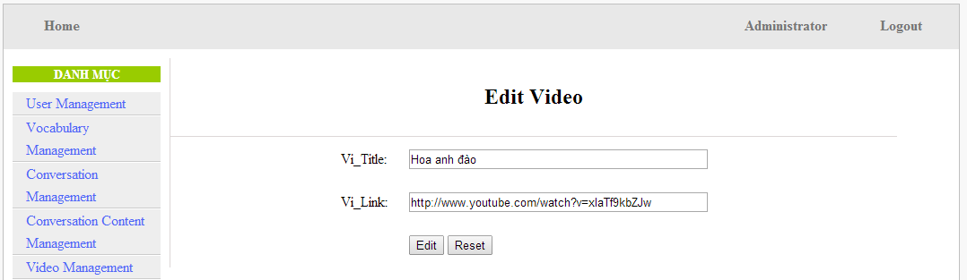

Figure 11.3: Edit video

Table 11.3: Edit video’s screen description:

|  |  |  |  |  |  |  |
| --- | --- | --- | --- | --- | --- | --- |
| No | Field name | Type | Require | Mandatory | Max-Length | Description |
| 1 | Title | Text | Text | Y | 200 | Admin input title with length less than 200 characters |
| 2 | Link | Text | Text | Y | 1000 | Admin input hyperlink |
| 3 | Add | Button | Click | Y |  | Admin edit video |

|  |  |  |  |  |
| --- | --- | --- | --- | --- |
| **UC0042 - Specification** | | | | |
| **Use-case No.** | <UC0042> | **Use-case Version** | | <1.0> |
| **Use-case Name** | Edit video | | | |
| **Author** | Minh PT | | | |
| **Date** | 09/06/2014 | **Priority** | <High > | |
| **Actor:**  Admin  **Summary:**  When Administrator wants to edit video in database which has some new meanings or errors. When edit finished, new meaning will be updated  **Triggers**  User must click on “Video management” then search for the video. User click on “Edit” link corresponding with video. User edit necessary information of video in the right fields then click on “Edit” button.  **Preconditions:**   * Website is available * User have logged into system as an admin. * All mandatory fields have been filled * All input data must be valid and have not existed in system   **Post Conditions:**  Changed information of video has been saved into system database successfully  **Main Success Scenario:**   |  |  |  | | --- | --- | --- | | **Step** | **User** | **System** | | 1 | Have logged into system as an admin |  | | 2 | Click on “Video management ” then search for the video that they want to edit | Displays search result as a table | | 3 | Click on “Edit” link corresponding | Display “Edit video” screen that contains the information of chosen video with these elements:   * Title * Link | | 4 | Edit video information and click “Edit” button | The system validates the input data and then save data into database |     **Alternative Scenario:**   |  |  |  | | --- | --- | --- | | **At Step** | **User** | **System** | | 4 | Edit video then click to another link | Do not save edited data then redirect to selected page |   **Exceptions:**   |  |  |  | | --- | --- | --- | | **At Step** | **User** | **System** | | 4 | Edit video to be similar to another existed video and click “Edit” button | The system validates the input data and return Error message and do not save edited data into database |   **Reference:**  UC0040- <Admin> Search video | | | | |

##### UC043 <Video management>: Delete video

|  |  |  |  |  |
| --- | --- | --- | --- | --- |
| **UC0043 - Specification** | | | | |
| **Use-case No.** | <UC0043> | **Use-case Version** | | <1.0> |
| **Use-case Name** | Delete video | | | |
| **Author** | Minh PT | | | |
| **Date** | 09/06/2014 | **Priority** | <High > | |
| **Actor:**  Admin  **Summary:**  When Administrator wants to delete video in database  **Triggers**  User must click on “Video management” then search for the video. User click on “Delete” link on corresponding video.  **Preconditions:**   * Website is available * User have logged into system as an admin.   **Post Conditions:**  Video has been deleted from system database successfully  **Main Success Scenario:**   |  |  |  | | --- | --- | --- | | **Step** | **User** | **System** | | 1 | Have logged into system as an admin |  | | 2 | Click on “Video management ” then search for the video that they want to delete | Displays search result as a table | | 3 | Click on “Delete” link corresponding with conversation | Remove that video in database |     **Reference:**  UC0040 - <Admin> Search video | | | | |
|  | | | | |

### リスニング·マネージメント

#### 使用事例図表

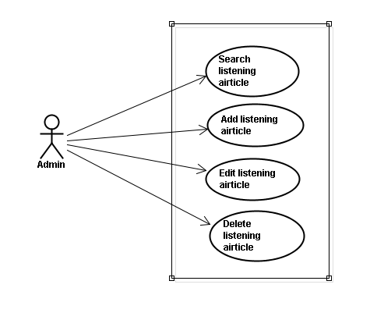

#### スクリーン•デスクリプション

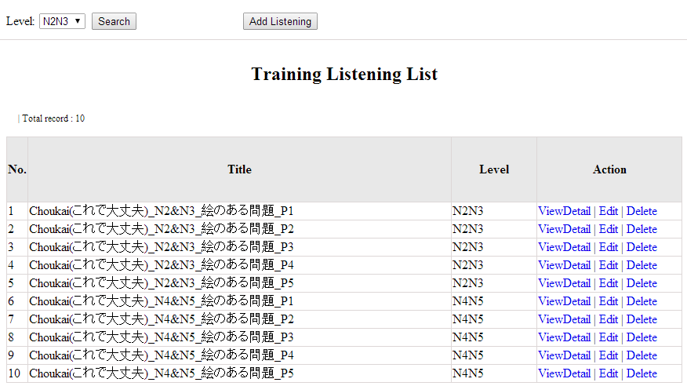

Figure 12: Listening article management

Table 12.1: Conversation management’s screen description:

|  |  |  |  |  |  |  |
| --- | --- | --- | --- | --- | --- | --- |
| No | Field name | Type | Require | Mandatory | Max-Length | Description |
| 1 | Level | Drop-down list | Click | Y |  | Admin choose the level |
| 2 | Search | Button | Click | Y |  | Admin click to search |
| 3 | Addnew | Button | Click | N |  | Admin add new listening into database |
| 4 | ViewDetail | Hyperlink | Click | N |  | Admin click to view details of listening |
| 5 | Edit | Button | Click | N |  | Admin click edit listening article |
| 6 | Delete | Button | Click | N |  | Admin click delete article |

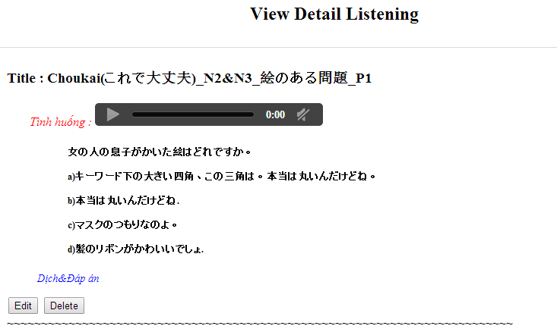

#### 使用書例仕様

##### UC044 <Listening Article Management>: Search listening article

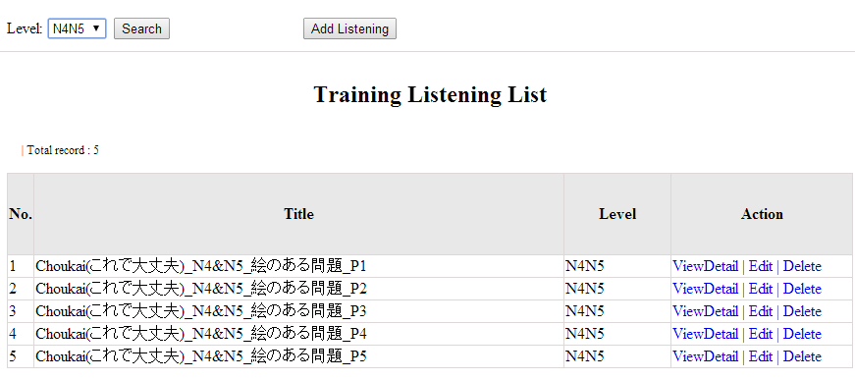

Figure 12.1: Search listening article

|  |  |  |  |  |
| --- | --- | --- | --- | --- |
| **UC0044 - Specification** | | | | |
| **Use-case No.** | <UC0044> | **Use-case Version** | | <1.0> |
| **Use-case Name** | Search listening article | | | |
| **Author** | Minh PT | | | |
| **Date** | 09/06/2014 | **Priority** | <High > | |
| **Actor:**  Admin  **Summary:**  When Administrator wants to search listening article in database. User input listening id or listening level then click “Search” button  **Triggers**  Click on “Listening practice management” tab, input listening id or level in the right text box then click “Search” button  **Preconditions:**   * Website is available * User has to login as Administrator * User has to input data in search area   **Post Conditions:**  Display detail information of listening article  **Main Success Scenario:**   |  |  |  | | --- | --- | --- | | **Step** | **User** | **System** | | 1 | Have logged into system as an admin |  | | 2 | Click on “Listening article management” tab | Displays criteria search screen | | 3 | Fill information of the listening article that they want to find into lis_id or lis_level then click “Search” button | Displays search result as a table with these elements:   * No * Title * Level * View details * Edit * Delete |     **Alternative Scenario:**   |  |  |  | | --- | --- | --- | | **At Step** | **User** | **System** | | 3 | Fill information of the listening article that they want to find into these fields then click on another link | Switch to selected page |   **Exceptions:**   |  |  |  | | --- | --- | --- | | **At Step** | **User** | **System** | | 3 | Fill information of the listening article that they want to find (that do not exited in database) into these fields then click “Search” button | Return Error message to inform that listening article cannot be found | | | | | |

##### UC045 <Listening Article Management>: Add listening article

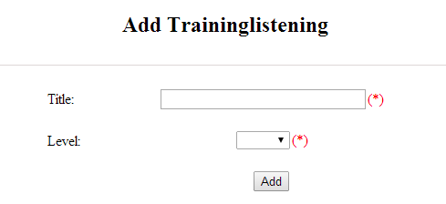

Figure 12.2: Add listening :

Table 12.2: Add listening’s screen description:

|  |  |  |  |  |  |  |
| --- | --- | --- | --- | --- | --- | --- |
| No | Field name | Type | Require | Mandatory | Max-Length | Description |
| 1 | Title | Text | Text | Y | 500 | Admin input id with length less than 500 characters |
| 2 | Level | Drop-down list | Choose | Y |  | Admin choose level |
| 3 | Add | Button | Click | Y |  | Admin add new listening |

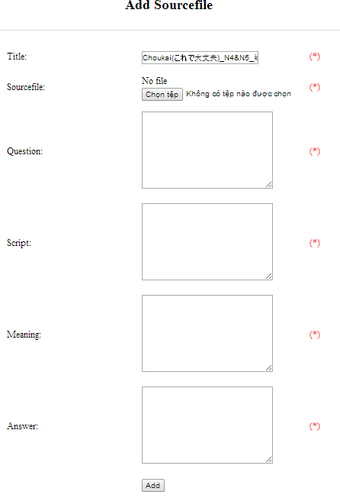

Figure 12.2.1: Add listening source file:

Table 12.2.1: Add listening source file’s screen description:

|  |  |  |  |  |  |  |
| --- | --- | --- | --- | --- | --- | --- |
| No | Field name | Type | Require | Mandatory | Max-Length | Description |
| 1 | Source_file | Button | Click | Y |  | Admin choose the file |
| 2 | Question | Text | Text | Y | 5000 | Admin input question of listening with length less than 5000 characters |
| 3 | Script | Text | Text | Y | 5000 | Admin input script of listening with length less than 5000 characters |
| 4 | Meaning | Text | Text | Y | 5000 | Admin input meaning of listening with length less than 5000 characters |
| 5 | Answer | Text | Text | Y | 5000 | Admin input answer of listening with length less than 5000 characters |
| 6 | Add | Button | Click | Y |  | Admin add source file |

|  |  |  |  |  |
| --- | --- | --- | --- | --- |
| **UC0045 - Specification** | | | | |
| **Use-case No.** | <UC0045> | **Use-case Version** | | <1.0> |
| **Use-case Name** | Add listening article | | | |
| **Author** | Minh PT | | | |
| **Date** | 09/06/2014 | **Priority** | <High > | |
| **Actor:**  Admin  **Summary:**  When Administrator wants to add new listening article into database. They have to insert all necessary data of listening article into “Add new listening” screen  **Triggers**  User must click on “Listening management/ Add New” and input all necessary information of listening article into the right fields then click on “Add” button  **Preconditions:**   * Website is available * User have logged into system as an admin. * All mandatory fields have been filled * All input data must be valid and have not existed in system   **Post Conditions:**  New listening article has been saved into system database successfully  **Main Success Scenario:**   |  |  |  | | --- | --- | --- | | **Step** | **User** | **System** | | 1 | Have logged into system as an admin |  | | 2 | Click on “Listening article management/Add New” | Display “Add New Listening” screen that contains these elements:   * Title * Level | | 3 | Fill listening article information into all necessary or mandatory fields click “Add” button | The system validates the input data and then save new listening article data into database | | 4 | Click on “Listening article management/View details/ Add source file” | Display “Add source file” screen that contains these elements:   * Title * Source file * Question * Script * Meaning * Answer | | 5 | Fill listening article information into all necessary or mandatory fields click “Add” button | The system validates the input data and then save new listening article data into database |     **Alternative Scenario:**   |  |  |  | | --- | --- | --- | | **At Step** | **User** | **System** | | 3 | Click on another link | Do not save new listening article data into database then redirect to selected page | | 5 | Click on another link | Do not save new source file data into database then redirect to selected page |   **Exceptions:**   |  |  |  | | --- | --- | --- | | **At Step** | **User** | **System** | | 3 | Do not fill full information into fields then click “Add” button | Return Error message and request user input data into all fields | | 5 | Do not fill full information into fields then click “Add” button | Return Error message and request user input data into all fields | | | | | |

##### UC046 <Listening Article Management>: Edit listening article

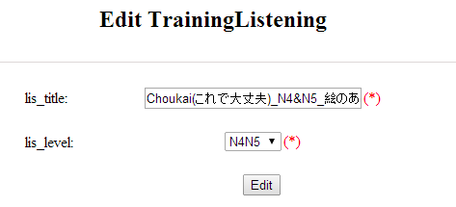

Figure 12.3: Edit listening:

Table 12.3: Edit listening ’s screen description:

|  |  |  |  |  |  |  |
| --- | --- | --- | --- | --- | --- | --- |
| No | Field name | Type | Require | Mandatory | Max-Length | Description |
| 1 | Title | Text | Text | Y | 500 | Admin input id with length less than 500 characters |
| 2 | Level | Drop-down list | Choose | Y |  | Admin choose level |
| 3 | Edit | Button | Click | Y |  | Admin edit listening |

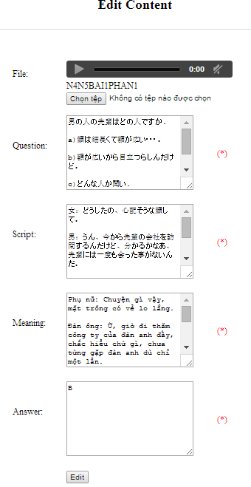

Figure 12.3.1: Edit listening source file:

Table 12.3.1: Edit listening source file’s screen description:

|  |  |  |  |  |  |  |
| --- | --- | --- | --- | --- | --- | --- |
| No | Field name | Type | Require | Mandatory | Max-Length | Description |
| 1 | Source_file | Button | Click | Y |  | Admin choose the file |
| 2 | Question | Text | Text | Y | 5000 | Admin input question of listening with length less than 5000 characters |
| 3 | Script | Text | Text | Y | 5000 | Admin input script of listening with length less than 5000 characters |
| 4 | Meaning | Text | Text | Y | 5000 | Admin input meaning of listening with length less than 5000 characters |
| 5 | Answer | Text | Text | Y | 5000 | Admin input answer of listening with length less than 5000 characters |
| 6 | Edit | Button | Click | Y |  | Admin edit source file |

|  |  |  |  |  |
| --- | --- | --- | --- | --- |
| **UC0046 - Specification** | | | | |
| **Use-case No.** | <UC0046> | **Use-case Version** | | <1.0> |
| **Use-case Name** | Edit listening article | | | |
| **Author** | Minh PT | | | |
| **Date** | 09/06/2014 | **Priority** | <High > | |
| **Actor:**  Admin  **Summary:**  When Administrator wants to edit listening article in database which has some new meanings or errors. When edit finished, new meaning will be updated  **Triggers**  User must click on “Listening management” then search for the listening article. User click on “Edit” link corresponding with listening article. They edit necessary information of listening article in the right fields then click on “Edit” button.  **Preconditions:**   * Website is available * User have logged into system as an admin. * All mandatory fields have been filled * All input data must be valid and have not existed in system   **Post Conditions:**  Changed information of listening article has been saved into system database successfully  **Main Success Scenario:**   |  |  |  | | --- | --- | --- | | **Step** | **User** | **System** | | 1 | Have logged into system as an admin |  | | 2 | Click on “Trainig listening” then search for the listening article that they want to edit | Displays search result as a table | | 3 | Click on “Edit” link corresponding | Display “Edit listening” screen that contains the information of chosen listening article with these elements:   * Title * Level | | 4 | Edit listening article information and click “Edit” button | The system validates the input data and then save data into database | | 5 | Click on “View details/ Edit” link corresponding | Display “Edit listening” screen that contains the information of chosen listening article with these elements:   * File * Question * Script * Meaning * Answer | | 6 | Edit listening article information and click “Edit” button | The system validates the input data and then save data into database |     **Alternative Scenario:**   |  |  |  | | --- | --- | --- | | **At Step** | **User** | **System** | | 4 | Edit listening article then click to another link | Do not save edited data then redirect to selected page | | 6 | Edit listening article then click to another link | Do not save edited data then redirect to selected page |   **Exceptions:**   |  |  |  | | --- | --- | --- | | **At Step** | **User** | **System** | | 4 | Edit listening article to be similar to another existed listening article click “Edit” button | The system validates the input data and return Error message and do not save edited data into database | | 6 | Edit listening article to be similar to another existed listening article click “Edit” button | The system validates the input data and return Error message and do not save edited data into database |   **Reference:**  UC0044- <Admin> Search listening article | | | | |

##### UC047 <Listening Article Management>: Delete listening article

|  |  |  |  |  |
| --- | --- | --- | --- | --- |
| **UC0047 - Specification** | | | | |
| **Use-case No.** | <UC0047> | **Use-case Version** | | <1.0> |
| **Use-case Name** | Delete listening article | | | |
| **Author** | Minh PT | | | |
| **Date** | 09/06/2014 | **Priority** | <High > | |
| **Actor:**  Admin  **Summary:**  When Administrator want to delete listening article inn database  **Triggers**  User must click on “Listening article management” then search for the listening article. User click on “Delete” link corresponding with listening article.  **Preconditions:**   * Website is available * User have logged into system as an admin.   **Post Conditions:**  Listening article has been deleted from system database successfully  **Main Success Scenario:**   |  |  |  | | --- | --- | --- | | **Step** | **User** | **System** | | 1 | Have logged into system as an admin |  | | 2 | Click on “Listening article management ” then search for the listening article that they want to delete | Displays search result as a table | | 3 | Click on “Delete” link corresponding | Remove that listening article in database |     **Reference:**  UC0044 - <Admin> Search listening article | | | | |
|  | | | | |

### テスト·マネージメント

#### 使用事例図表

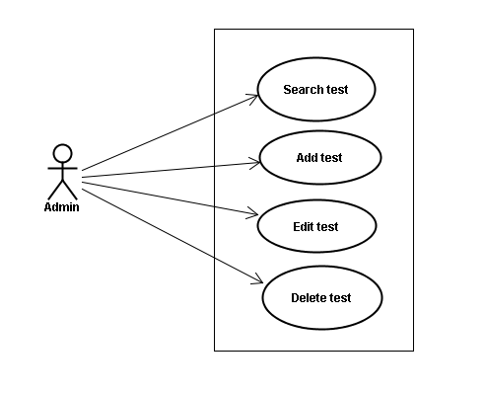

#### スクリーン•デスクリプション

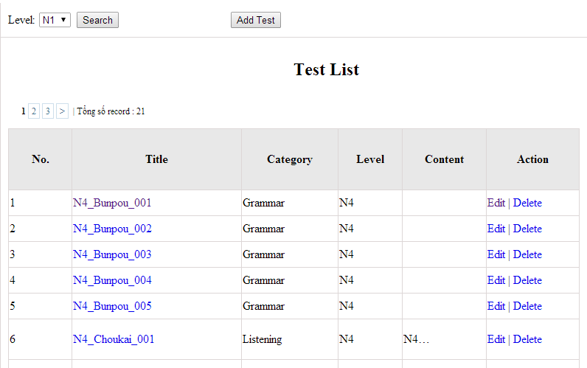

Figure 13: Doing test management

Table 13.1: Doing test management’s screen description:

|  |  |  |  |  |  |  |
| --- | --- | --- | --- | --- | --- | --- |
| No | Field name | Type | Require | Mandatory | Max-Length | Description |
| 1 | Level | Drop-down list | Click | N |  | Admin choose the level |
| 2 | Search | Button | Click | N |  | Admin click to search |
| 3 | List | Hyperlink | Click | N |  | Admin click to view details |
| 4 | Edit | Button | Click | N |  | Admin click edit test |
| 5 | Delete | Button | Click | N |  | Admin click delete test |

#### 使用書例仕様

##### UC048 <Test management>: Search test

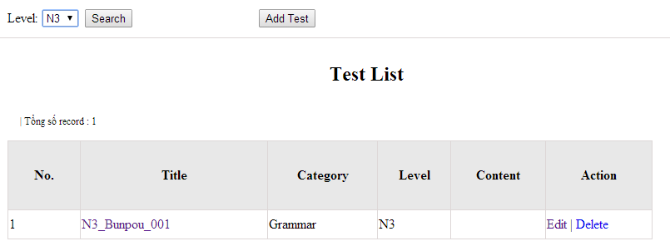

Figure 13.1: Search test:

|  |  |  |  |  |
| --- | --- | --- | --- | --- |
| **UC0048 - Specification** | | | | |
| **Use-case No.** | <UC0048> | **Use-case Version** | | <1.0> |
| **Use-case Name** | Search test | | | |
| **Author** | Minh PT | | | |
| **Date** | 09/06/2014 | **Priority** | <High > | |
| **Actor:**  Admin  **Summary:**  When Administrator wants to search test article in database. User input test id or test category then click “Search” button.  **Triggers**  Click on “Test management” tab, input Test_id or test_ in the right text box then click “Search” button  **Preconditions:**   * Website is available * User has to login as Administrator * User has to input data in search area   **Post Conditions:**  Display detail information of that test  **Main Success Scenario:**   |  |  |  | | --- | --- | --- | | **Step** | **User** | **System** | | 1 | Have logged into system as an admin |  | | 2 | Click on “Test management” tab | Displays criteria search screen | | 3 | Fill information of the test that they want to find into test_id or test_catagory then click “Search” button | Displays search result as a table with these elements:   * No * Title * Category * Level * Content * Edit * Delete |     **Alternative Scenario:**   |  |  |  | | --- | --- | --- | | **At Step** | **User** | **System** | | 3 | Fill information of the test that they want to find into these fields then click on another link | Switch to selected page |   **Exceptions:**   |  |  |  | | --- | --- | --- | | **At Step** | **User** | **System** | | 3 | Fill information of the test that they want to find (that do not exited in database) into these fields then click “Search” button | Return Error message to inform that test cannot be found | | | | | |

##### UC049 <Test management>: Add test

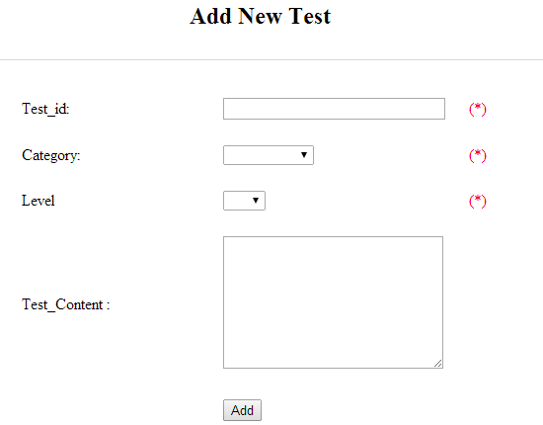

Figure 13.2: Add test

Table 13.2 : Add test’s screen description:

|  |  |  |  |  |  |  |
| --- | --- | --- | --- | --- | --- | --- |
| No | Field name | Type | Require | Mandatory | Max-Length | Description |
| 1 | ID | Text | Text | Y | 100 | Admin input id with length less than 100 characters |
| 2 | Category | Drop-down list | Click | Y |  | Admin choose category |
| 3 | Level | Drop-down list | Click | Y |  | Admin choose level of test |
| 4 | Test content | Text | Text | Y | 5000 | Admin input content with length less than 5000 characters |
| 5 | Add | Button | Click | Y |  | Admin click to add test |

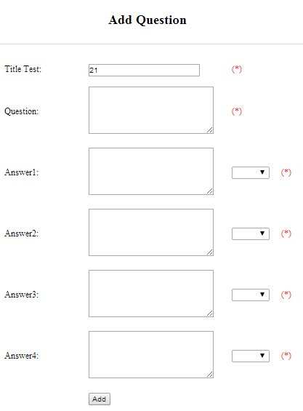

Figure 13.2.1: Add question

Table 13.2.1: Add question’s screen description:

|  |  |  |  |  |  |  |
| --- | --- | --- | --- | --- | --- | --- |
| No | Field name | Type | Require | Mandatory | Max-Length | Description |
| 1 | Question | Text | Text | Y | 200 | Admin input question with length less than 200 characters |
| 2 | Answer 1 | Text | Text | Y | 200 | Admin input answer 1 with length less than 200 characters |
| 3 | Correct answer 1 | Drop-down list | Click | Y |  | Admin choose correct answer |
| 4 | Answer 2 | Text | Text | Y | 200 | Admin input answer 2 with length less than 200 characters |
| 5 | Correct answer 2 | Drop-down list | Click | Y |  | Admin choose correct answer |
| 6 | Answer 3 | Text | Text | Y | 200 | Admin input answer 3 with length less than 200 characters |
| 7 | Correct answer 3 | Drop-down list | Click | Y |  | Admin choose correct answer |
| 8 | Answer 4 | Text | Text | Y | 200 | Admin input answer 4 with length less than 200 characters |
| 9 | Correct answer 4 | Drop-down list | Click | Y |  | Admin choose correct answer |
| 10 | Add | Button | Click | Y |  | Admin click to add |

|  |  |  |  |  |
| --- | --- | --- | --- | --- |
| **UC0049 - Specification** | | | | |
| **Use-case No.** | <UC0049> | **Use-case Version** | | <1.0> |
| **Use-case Name** | Add test | | | |
| **Author** | Minh PT | | | |
| **Date** | 09/06/2014 | **Priority** | <High > | |
| **Actor:**  Admin  **Summary:**  When Administrator want to add new test into database. They have to insert all necessary data of test into “Add new test” screen  **Triggers**  User must click on “Test management/ Add New” and input all necessary information of test into the right fields then click on “Add” button  **Preconditions:**   * Website is available * User have logged into system as an admin. * All mandatory fields have been filled * All input data must be valid and have not existed in system   **Post Conditions:**  New test has been saved into system database successfully  **Main Success Scenario:**   |  |  |  | | --- | --- | --- | | **Step** | **User** | **System** | | 1 | Have logged into system as an admin |  | | 2 | Click on “Test management/Add New” | Display “Add New Test” screen that contains these elements:   * Title * Category * Level * Content | | 3 | Fill test information into all necessary or mandatory fields and click “Add” button | The system validates the input data and then save new test data into database | | 4 | Click on “Title link/Add new question” | Display “Add New Question” screen that contains these elements:   * Title * Question * Answer 1 * Correct answer 1 * Answer 2 * Correct answer 2 * Answer 3 * Correct answer 3 * Answer 4 * Correct answer 4 | | 5 | Fill test information into all necessary or mandatory fields and click “Add” button | The system validates the input data and then save new test data into database |     **Alternative Scenario:**   |  |  |  | | --- | --- | --- | | **At Step** | **User** | **System** | | 3 | Click on another link | Do not save new test data into database then redirect to selected page | | 5 | Click on another link | Do not save new question data into database then redirect to selected page |   **Exceptions:**   |  |  |  | | --- | --- | --- | | **At Step** | **User** | **System** | | 3 | Do not fill full information into fields then click “Add” button | Return Error message and request user input data into all fields | | 5 | Do not fill full information into fields then click “Add” button | Return Error message and request user input data into all fields | | | | | |

##### UC050 <Test management>: Edit test

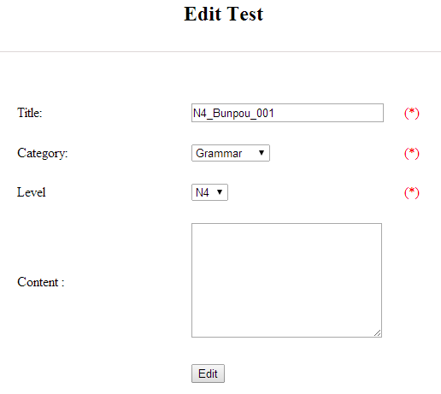

Figure 13.3: Edit test

Table 13.3: Edit test’s screen description:

|  |  |  |  |  |  |  |
| --- | --- | --- | --- | --- | --- | --- |
| No | Field name | Type | Require | Mandatory | Max-Length | Description |
| 1 | ID | Text | Text | Y | 100 | Admin input id with length less than 100 characters |
| 2 | Category | Drop-down list | Click | Y |  | Admin choose category |
| 3 | Level | Drop-down list | Click | Y |  | Admin choose level of test |
| 4 | Test content | Text | Text | Y | 5000 | Admin input content with length less than 5000 characters |
| 5 | Edit | Button | Click | Y |  | Admin click to edit test |

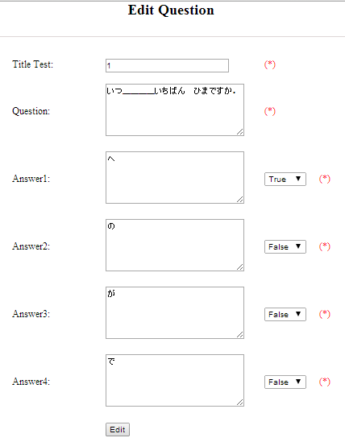

Figure 13.3.1: Edit question

Table 13.3.1: Edit question’s screen description:

|  |  |  |  |  |  |  |
| --- | --- | --- | --- | --- | --- | --- |
| No | Field name | Type | Require | Mandatory | Max-Length | Description |
| 1 | Question | Text | Text | Y | 200 | Admin input question with length less than 200 characters |
| 2 | Answer 1 | Text | Text | Y | 200 | Admin input answer 1 with length less than 200 characters |
| 3 | Correct answer 1 | Drop-down list | Click | Y |  | Admin choose correct answer |
| 4 | Answer 2 | Text | Text | Y | 200 | Admin input answer 2 with length less than 200 characters |
| 5 | Correct answer 2 | Drop-down list | Click | Y |  | Admin choose correct answer |
| 6 | Answer 3 | Text | Text | Y | 200 | Admin input answer 3 with length less than 200 characters |
| 7 | Correct answer 3 | Drop-down list | Click | Y |  | Admin choose correct answer |
| 8 | Answer 4 | Text | Text | Y | 200 | Admin input answer 4 with length less than 200 characters |
| 9 | Correct answer 4 | Drop-down list | Click | Y |  | Admin choose correct answer |
| 10 | Edit | Button | Click | Y |  | Admin click to edit |

|  |  |  |  |  |
| --- | --- | --- | --- | --- |
| **UC0050 - Specification** | | | | |
| **Use-case No.** | <UC0050> | **Use-case Version** | | <1.0> |
| **Use-case Name** | Edit test | | | |
| **Author** | Minh PT | | | |
| **Date** | 09/06/2014 | **Priority** | <High > | |
| **Actor:**  Admin  **Summary:**  When Administrator want to edit test in database which has some new meanings or errors. When edit finished, new meaning will be updated  **Triggers**  User must click on “Test management” then search for the test. User click on “Edit” link on corresponding test. User edit necessary information of test in the right fields then click on “Edit” button.  **Preconditions:**   * Website is available * User have logged into system as an admin. * All mandatory fields have been filled * All input data must be valid and have not existed in system   **Post Conditions:**  Changed information of test has been saved into system database successfully  **Main Success Scenario:**   |  |  |  | | --- | --- | --- | | **Step** | **User** | **System** | | 1 | Have logged into system as an admin |  | | 2 | Click on “Test management ” then search for the test that they want to edit | Displays search result as a table | | 3 | Click on “Edit” link corresponding | Display “Edit Test” screen that contains the information of chosen test with these elements:   * Title * Category * Level * Content | | 4 | Edit test information and click “Edit” button | The system validates the input data and then save data into database |     **Alternative Scenario:**   |  |  |  | | --- | --- | --- | | **At Step** | **User** | **System** | | 4 | Edit test then click to another link | Do not save edited data then redirect to selected page |   **Exceptions:**   |  |  |  | | --- | --- | --- | | **At Step** | **User** | **System** | | 4 | Edit test to be similar to another existed test and click “Edit” button | The system validates the input data and return Error message and do not save edited data into database |   **Reference:**  UC0048- <Admin> Search test | | | | |

##### UC051 <Test management>: Delete test

|  |  |  |  |  |
| --- | --- | --- | --- | --- |
| **UC0051 - Specification** | | | | |
| **Use-case No.** | <UC0051> | **Use-case Version** | | <1.0> |
| **Use-case Name** | Delete test | | | |
| **Author** | Minh PT | | | |
| **Date** | 09/06/2014 | **Priority** | <High > | |
| **Actor:**  Admin  **Summary:**  When Administrator want to delete test in database  **Triggers**  User must click on “Test management” then search for the test. User click on “Delete” link corresponding with test.  **Preconditions:**   * Website is available * User have logged into system as an admin.   **Post Conditions:**  Test has been deleted from system database successfully  **Main Success Scenario:**   |  |  |  | | --- | --- | --- | | **Step** | **User** | **System** | | 1 | Have logged into system as an admin |  | | 2 | Click on “Test management ” then search for the test that they want to delete | Displays search result as a table | | 3 | Click on “Delete” link corresponding | Remove that test in database |     **Reference:**  UC0048 - <Admin> Search test | | | | |
|  | | | | |

### 貢献識見·マネージメント

#### 使用事例図表

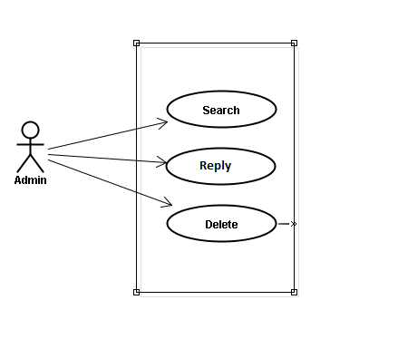

#### 使用書例仕様

##### UC052 <Opinion/Q&A Management>: Search question

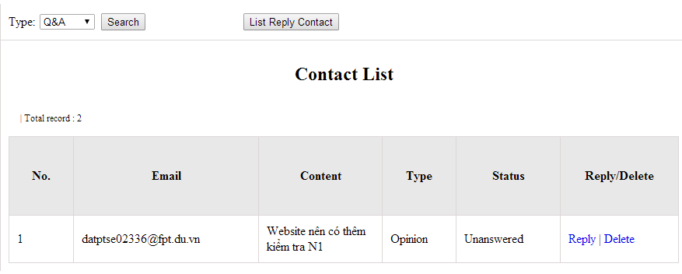

Figure 14.1: Search contact management’s screen

Table 14.1: Search contact management’s screen description

|  |  |  |  |  |  |  |
| --- | --- | --- | --- | --- | --- | --- |
| No | Field name | Type | Require | Mandatory | Max-Length | Description |
| 1 | Type | Drop-down list | Click | N |  | Admin choose the typ |
| 2 | Search | Button | Click | N |  | Admin click to search |
| 3 | Reply | Button | Click | N |  | Admin click reply the question |
| 4 | Delete | Button | Click | N |  | Admin click delete question |
| 5 | List reply | Button | Click | N |  | Admin click to view list reply |

|  |  |  |  |  |
| --- | --- | --- | --- | --- |
| **UC0055 – Specification** | | | | |
| **Use-case No.** | <UC0055> | **Use-case Version** | | <1.0> |
| **Use-case Name** | Search question | | | |
| **Author** | Minh PT | | | |
| **Date** | 09/06/2014 | **Priority** | <High > | |
| **Actor:**  Admin  **Summary:**  When administrator wants to search question from member. User input data then click “Search” button.  **Triggers**  Click on “Contact Management ” tab, input data in the right text box then click “Search” button  **Preconditions:**   * Website is available * User has to login as Administrator * User has to input data in search area   **Post Conditions:**  Display detail information of question  **Main Success Scenario:**   |  |  |  | | --- | --- | --- | | **Step** | **User** | **System** | | 1 | Have logged into system as an admin |  | | 2 | Click on “Contact Management ” tab | Displays criteria search screen | | 3 | Fill information that they want to find into text box then click “Search” button | Displays search result as a table with these elements:   * No * Email * Content * Type * Status * Reply * Delete |     **Alternative Scenario:**   |  |  |  | | --- | --- | --- | | **At Step** | **User** | **System** | | 3 | Fill information that they want to find into these fields then click on another link | Switch to selected page |   **Exceptions:**   |  |  |  | | --- | --- | --- | | **At Step** | **User** | **System** | | 3 | Fill information that they want to find (that do not exited in database) into these fields then click “Search” button | Return Error message to inform that cannot be found | | | | | |

##### UC053 <Opinion/Q&A Management>: Reply question

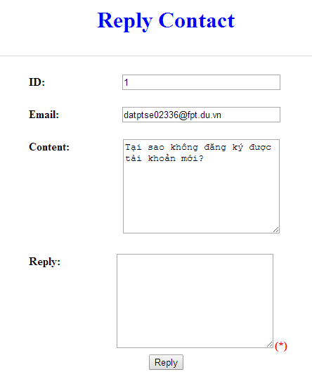

Figure 16.2 : Reply contact

Table 16.2: Reply contact’s screen description:

|  |  |  |  |  |  |  |
| --- | --- | --- | --- | --- | --- | --- |
| No | Field name | Type | Require | Mandatory | Max-Length | Description |
| 1 | Email |  |  |  |  | Email of admin’s account |
| 2 | Content |  |  |  |  | Question |
| 3 | Reply | Text | Text | Y |  | Admin input reply of question |
| 4 | Reply | Button | Click | N |  | Admin click send reply question |

|  |  |  |  |  |
| --- | --- | --- | --- | --- |
| **UC0056 - Specification** | | | | |
| **Use-case No.** | <UC0056> | **Use-case Version** | | <1.0> |
| **Use-case Name** | Search question | | | |
| **Author** | Minh PT | | | |
| **Date** | 09/06/2014 | **Priority** | <High > | |
| **Actor:**  Admin  **Summary:**  When administrator wants to reply question from member.  **Triggers**  Click on “Opinion/Q&A Management ” tab, User search question then click “Reply” link corresponding  **Preconditions:**   * Website is available * User has to login as Administrator * User has to input answer   **Post Conditions:**  Answer be sent to user  **Main Success Scenario:**   |  |  |  | | --- | --- | --- | | **Step** | **User** | **System** | | 1 | Have logged into system as an admin |  | | 2 | Click on “Opinion/Q&A Management ” tab | Displays criteria search screen | | 3 | Click “Reply” link corresponding | Displays Reply screen with these elements:   * Email * Content * Reply | | 4 | Input the answer and click “Reply” button | The answer of question will be sent to member |     **Alternative Scenario:**   |  |  |  | | --- | --- | --- | | **At Step** | **User** | **System** | | 4 | Input answer then click on another link | Switch to selected page |   **Exceptions:**   |  |  |  | | --- | --- | --- | | **At Step** | **User** | **System** | |  |  |  |   **Reference:**  UC0052 - < Opinion/Q&A Management > Search question | | | | |

##### UC054 <Opinion/Q&A Management>: Delete question

|  |  |  |  |  |
| --- | --- | --- | --- | --- |
| **UC0054 - Specification** | | | | |
| **Use-case No.** | <UC0051> | **Use-case Version** | | <1.0> |
| **Use-case Name** | Delete question | | | |
| **Author** | Minh PT | | | |
| **Date** | 09/06/2014 | **Priority** | <High > | |
| **Actor:**  Admin  **Summary:**  When Administrator want to delete question  **Triggers**  User must click on “Contact management” then search for the test. User click on “Delete” link corresponding with test.  **Preconditions:**   * Website is available * User have logged into system as an admin.   **Post Conditions:**  Question has been deleted from system database successfully  **Main Success Scenario:**   |  |  |  | | --- | --- | --- | | **Step** | **User** | **System** | | 1 | Have logged into system as an admin |  | | 2 | Click on “Contact management ” then search for the test that they want to delete | Displays search result as a table | | 3 | Click on “Delete” link corresponding | Remove that test in database |     **Reference:**  UC0052 - <Admin> Search contact | | | | |
|  | | | | |

### 貢献含量マネージメント

#### 使用事例図表

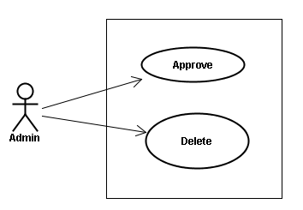

#### 使用書例仕様

##### UC055 <Contact’s content Management>: Approve contribute content

Approve contribute content screen:

1. Approve contribute kanji screen:

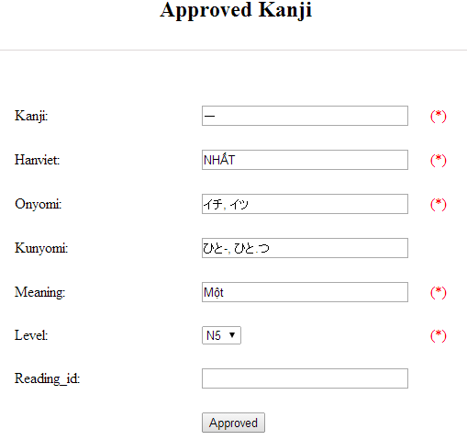

Figure 15.1: Approved kanji’s screen

Table 15.1: Approved kanji’s screen description

|  |  |  |  |  |  |  |  |
| --- | --- | --- | --- | --- | --- | --- | --- |
| No | Field name | File name in Vietnamese | Type | Require | Mandatory | Max-Length | Description |
| 1 | Kanji | Kanji | Text | Text | Y | 10 | Admin input kanji with length less than 10 characters |
| 2 | HanViet | Hán Việt | Text | Text | N | 50 | Admin input to the field with length less than 50 characters |
| 3 | Onyomi | Âm Onyomi | Text | Text | Y | 100 | Admin input onyomi with length less than 100 characters |
| 4 | Kunyomi | Âm kunyomi | Text | Text | Y | 100 | Admin input kunyomi with length less than 100 characters |
| 5 | Meaning | Nghĩa | Text | Text | Y | 200 | Admin input meaning with length less than 200 characters |
| 6 | Level | Level | Drop-down list | Click | Y |  | Admin choose the level |
| 7 | Reading_id |  | Text | Text | N | 20 | Admin input reading id with length less than 20 characters |
| 8 | Approved | Approved | Button | Click | Y |  | Admin click to approved contribute |

1. Approve contribute grammar screen:

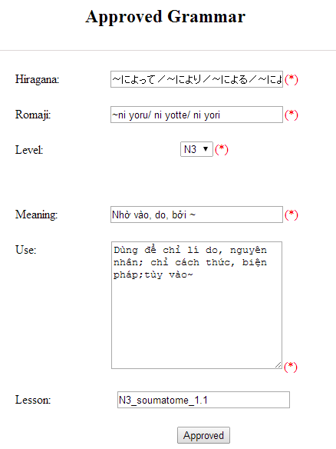

Figure 15.2: Approved grammar screen

Table 15.2: Approved grammar’s screen description:

|  |  |  |  |  |  |  |
| --- | --- | --- | --- | --- | --- | --- |
| No | Field name | Type | Require | Mandatory | Max-Length | Description |
| 1 | Hiragana | Text | Text | Y | 200 | Admin input hiragana with length less than 200 characters |
| 2 | Romaji | Text | Text | Y | 200 | Admin input romaji with length less than 200 characters |
| 3 | Meaning | Text | Text | Y | 200 | Admin input meaning with length less than 200 characters |
| 4 | Level | Drop-down list | Click | Y |  | Admin choose the level |
| 5 | Use | Text | Text | Y | 1000 | Admin input how to use with length less than 1000 characters |
| 6 | Lesson | Text | Text | N | 20 | Admin input lesson with length less than 20 characters |
| 7 | Approved | Button | Click | Y |  | Admin click to approved contribute |

1. Approve contribute vocabulary screen:

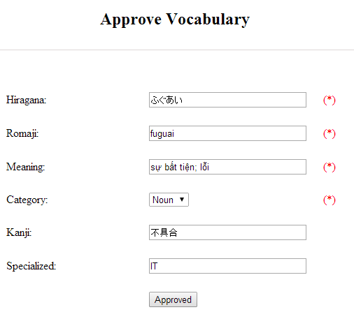

Table 15.3: Approved vocabulary

Table 15.3: Approved vocabulary’s screen description:

|  |  |  |  |  |  |  |
| --- | --- | --- | --- | --- | --- | --- |
| No | Field name | Type | Require | Mandatory | Max-Length | Description |
| 1 | Hiragana | Text | Text | Y | 200 | Admin input hiragana with length less than 200 characters |
| 2 | Romaji | Text | Text | N | 200 | Admin input romaji with length less than 200 characters |
| 3 | Meaning | Text | Text | Y | 500 | Admin input meaning with length less than 500 characters |
| 4 | Category | Drop-down list | Click | Y | 10 | Admin choose category |
| 5 | Kanji | Text | Text | N | 10 | Admin input kanji with length less than 10 characters |
| 6 | Specialized | Text | Text | N | 200 | Admin input specialized with length less than 200 characters |
| 7 | Approved | Button | Click | Y |  | Admin click to approved contribute |

|  |  |  |  |  |
| --- | --- | --- | --- | --- |
| **UC0053 - Specification** | | | | |
| **Use-case No.** | <UC0053> | **Use-case Version** | | <1.0> |
| **Use-case Name** | Approve contribute content | | | |
| **Author** | Minh PT | | | |
| **Date** | 09/06/2014 | **Priority** | <High > | |
| **Actor:**  Admin  **Summary:**  When administrator wants to approve contribute content include kanji, grammar, vocabulary in database. User click on link corresponding with kanji, grammar, vocabulary  **Triggers**  Click on “Contribute Kanji Management” or “Contribute Grammar Management” or “Contribute Vocabulary Management” tab, input data in the right text box then click “Search” button. Click on link corresponding with kanji, grammar, vocabulary which want to approve to database  **Preconditions:**   * Website is available * User has to login as Administrator * All mandatory fields have been filled * All input data must be valid and have not existed in system   **Post Conditions:**  Display detail information of contribute content  **Main Success Scenario:**   |  |  |  | | --- | --- | --- | | **Step** | **User** | **System** | | 1 | Have logged into system as an admin |  | | 2 | Click on “Kanji Management/List contribute kanji” or “Grammar Management/List contribute grammar” or “Vocabulary/List contribute vocabulary” tab | Displays criteria search screen | | 3 | Fill information that they want to find into text box then click “Search” button | Displays search result | | 4 | Click “Approved” link corresponding want to update into database | Display Approve kanji screen with these elements:   1. Kanji - Kanji - Âm hán - Âm Onyomi - Âm Kunyoumi - Meaning - level - Reading_id - Approved 2. Grammar: - Hiragana - Romaji - Level - Meaning - Use - Lesson - Approved 3. Vocabulary: - Hiragana - Romaji - Meaning - Category - Kanji - Specialized - Approved | | 5 | Edit or add more information and Click “Approved” button | The system validates the input data and then save data into database |     **Alternative Scenario:**   |  |  |  | | --- | --- | --- | | **At Step** | **User** | **System** | | 5 | Fill information then click on another link | Switch to selected page |   **Exceptions:**   |  |  |  | | --- | --- | --- | | **At Step** | **User** | **System** | | 5 | Fill information that exited in database into fields then click “Approved” button | Return Error message to inform that data is exiting in database |   **Reference:** | | | | |

##### UC0056: < Contact’s content Management > Delete contribute content

|  |  |  |  |  |
| --- | --- | --- | --- | --- |
| **UC0054 - Specification** | | | | |
| **Use-case No.** | <UC0054> | **Use-case Version** | | <1.0> |
| **Use-case Name** | Delete contribute content | | | |
| **Author** | Minh PT | | | |
| **Date** | 09/06/2014 | **Priority** | <High > | |
| **Actor:**  Admin  **Summary:**  When Administrator wants to delete a contribute content. Admin will search that content then click “Delete” link corresponding.  **Triggers**  User must click on “Contribute Kanji Management” or “Contribute Grammar Management” or “Contribute Vocabulary Management” tab then search for the contribute content. User click on “Delete” link corresponding with kanji, grammar, vocabulary which want to delete.  **Preconditions:**   * Website is available * User has to login as Administrator   **Post Conditions:**  Kanji, grammar, vocabulary have been deleted from list successfully  **Main Success Scenario:**   |  |  |  | | --- | --- | --- | | **Step** | **User** | **System** | | 1 | Have logged into system as an admin |  | | 2 | Click on “Contribute Kanji Management ” or “Contribute Grammar Management ” or “Contribute Vocabulary Management ” tab | Displays search result as a table | | 3 | Click on “Delete” link corresponding with kanji, grammar, vocabulary | Remove that kanji, grammar, vocabulary from list |   **Reference:** | | | | |
|  | | | | |

## 不機能的明示

### 確実

* Mean time between failures: The mean time between each failure is expected to be about 480 hours of using.
* Mean time to repair: Immediately when Administrator finds out problem or website is attacked/hacked by someone. Average 1 day.
* The maximum bugs per function are 2 bugs/a function when user uses software within 2 months. The average number of bugs in the software during system testing is about to be around 1 bugs/1000 LOC.
* The database must be backed up daily and can be recovered if necessary

### 実行·要件

#### 可用性

The application must be available 95% of time. Users can access to it everywhere from their

Web browser with internet connection.

#### 切り換え時

In term of response time, waiting time of processing will be 2 to 5 seconds; time to process any functions will not exceed 7 seconds.

### ユーザーインターフェ

● **Color:** The background color will be white and blue in default. The color of text will

be black or white.

● **Text:** All texts bases on Helvetica style and title or label will use upper case with the

first letter.

### 保守性

* **Coding standards and naming conventions**
  + Output of the project must include coding standards and naming conventions documentations. Implementation code must be easy to maintain.
  + All code must be clearly commented, including class, method documentations.
  + If some components are reused, the documentations of those components must also be included.
* **Design**
  + The design of the system must be loosely coupled that chances on some module will not affect others.
* **Logging**
  + All the errors should be logged, supporting for bug fixing and maintenance.
  + All strange or sensitive situations should also be logged.

### ユーザビリティ

Usability Requirements support the following from the perspective of its primary users:

● **Efficiency of use:** user can complete each function in less than 12 actions

● **Intuitiveness:** all help/error messages are simple to understand; user can know exactly how to do each feature after one time using it.

### 担保要件

In order to avoid unwanted access by strangers, the security implemented in various ways:

* **User layer**: Each function must be distributed system access and manipulate the individual parts. To edit information, user must declare their username and password before the operation. Functions will be show after users login dependencies user’s role and permission of each user.
* **Manage Data Layer**: Only Administrator can modify database system.
* **Stored Data**: All data about information of user, tested, etc.. will be saved in My SQL Server, and be easy for data classification or backup..

### 金物 · ソフトウェア要件

● **Hardware requirement:** PC/Laptop (window 7, window 8, window XP…)

● **Software requirements:** Web browser (Chrome, Firefox, IE…) with internet connection